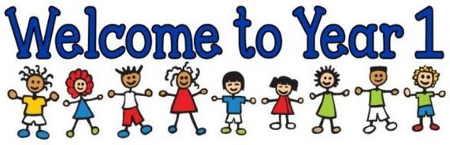
Year 1
English
We continue to use Read Write Inc to teach phonics. Your child will be learning all the phonemes and graphemes, through a differentiated approach. This will ensure that they are confident to segment and blend the learnt sounds when reading real and alien words. Also, your child will engage in daily reading through the scheme. They will read a text that is closely suited to their current phonetic knowledge. It will encourage them to segment and blend sounds they are familiar with, as well as ‘tricky’ words.
Your child will be sent home a Book Bag Book, which has been selected to reinforce their phonetical knowledge and reading skills outside of school. As a school, we recognise the importance of reading and suggest that 5 minutes is spent every night to enjoy reading together.
As writers, we will be using a picture book as a stimulus for our writing, through a Book as a Hook curriculum. This half term our book is ‘Am I Yours?’. We will be practising our sentences out loud before we write them down. We will also be using a sound mat to ensure that we are trying our best to spell words accurately. We will be writing recounts, stories and non-chronological reports that will all stem from our discovery of dinosaur eggs!

Religious Education

Our RE focus question is ‘What does it mean to belong?’

We will be exploring feelings associated with belonging in pupils’ own experiences and thinking about what it means to be part of a community. We will also reflect on the promises made at baptism and discussing the importance of keeping promises.

P.E. will take place on Mondays and Tuesday. Please ensure your child has a full P.E. kit in school with items labelled. Please also ensure all normal uniform is labelled to help to avoid any lost property.
Homework will be given out on a Monday and is due back in school on the following Monday. Your child will be given a homework folder to keep this in. This term, weekly homework will include Maths and the reading of their Book Bag Book. Pupils will also have the opportunity to complete a fun Creative Curriculum challenge when the task is sent out.

Computing
We will be thinking about what an algorithm is and how we can use them to programme the school Beebots. We will be debugging these algorithms when things don’t go to plan!
Curriculum Map Autumn Term
Creative Curriculum
This term our Creative Curriculum topic is Cracking Inventions!
We will be finding out all about famous inventors throughout history and their cracking inventions! We will be looking at George Stephenson who invented the railway and The Wright Brothers who invented the airplane. We will also be looking at the life of aviation pioneer Amy Johnson and tracking her journey from England to Australia on a world map.
Following this, we will investigate the invention of toys and comparing modern toys with toys from the Victorian era.

Science
Our focus this term is Animals including humans.
We will be identifying and grouping animals into the groups of fish, amphibians, reptiles, birds and mammals. We will also be finding out which animals are herbivores, omnivores and carnivores. We will be describing and comparing the structure of different animals. We will be learning about the basic parts of the human body and which part of the body is associated with each sense.
Our Art work will be linked to our Science learning as we will be sketching different animals. We will develop our sketching skills by using different weights of HB pencils to create tone and experiment with forming a variety of lines.

Maths
We will begin by learning about the place value of numbers to 10 and move onto learning the place value of numbers up to 20. We will also be discovering different strategies that will help us to confidently add and subtract numbers up to 10 and then to 20.
We will be learning through the Maths No Problem scheme, which encourages all learners to become actively engaged in their learning, efficient problem solvers and cooperative, resilient learners.

