Maths
We will begin by focussing on addition and subtraction by discovering different strategies that will help us to confidently add and subtract numbers up to 10 and then to 20. We will also be learning how to recognise and name 2D and 3D shapes and their properties.
Science
We will continue to focus on the topic ‘Animals including humans’. We will be identifying and grouping animals into the groups of fish,
amphibians, reptiles, birds and mammals. We will also be finding out which
animals are herbivores, omnivores and carnivores and describing and comparing the structure of different animals.
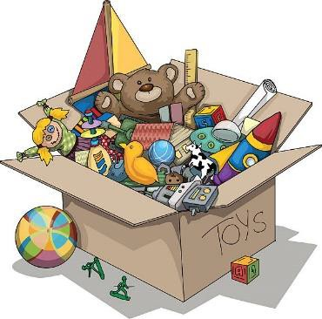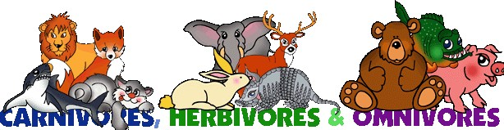Year 1 Curriculum Map Autumn 2
English
Your child will continue to be sent home a Read Write Inc. Book Bag Book, which has been selected to reinforce their phonetical knowledge and reading skills outside of school. As a school, we recognise the importance of reading and suggest that 5 minutes is spent every night to enjoy reading together.
As writers, we will be using a picture book as a stimulus for our writing, through a Book as a Hook curriculum. This half term our book is ‘Lost and Found’. We will be practising our sentences out loud before we write them down. We will also be using a sound mat to ensure that we are trying our best to spell words accurately. We will be writing stories, lists, captions and letters about the boy and the penguin’s journey to the South Pole!

Creative Curriculum
This half- term we will be continuing our topic on ‘Cracking Inventions’.
We will be focusing on the invention of toys. In particular, we will be comparing modern toys with toys from the Victorian era.
We will also have the exciting opportunity to visit Blackburn Museum to learn lots more about this topic!

P.E. will take place on Mondays and Tuesdays. Please ensure your child has a full P.E. kit in school with items labelled.
Homework will be given out on a Monday and is due back in school on the following Monday. Please ensure your child brings in their clear plastic homework folder as this is what new homework is put into to. Weekly homework includes a Maths worksheet, Read Write Inc. books and a reading for pleasure book.
Computing
We will be learning how to create and edit video content using software. We will bake a Christmas recipe and then film and edit the steps of the recipe.
Religious Education

Our RE focus question is ‘Why do Christians celebrate Christmas?’ We will gain an understanding of the Christmas story, explore our feelings associated with gift giving and enquire into how Christmas is celebrated in Church and at home.

