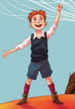

Year 3 Autumn Term

**As a writer we will be…**

* Writing a new description filled chapter to Roald Dahl’s story ‘James and the Giant peach’ and create newspaper reports about the events.

**As a reader we will be…**

* Listening to a range of stories by the famous author Roald Dahl and exploring his use of descriptive language.

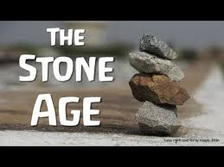

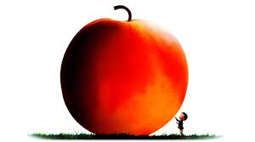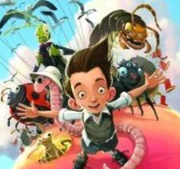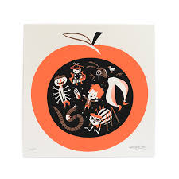

**As a mathematician we will be…**

* Learning about the place value of numbers up to 1000.
* Learning our 4 and 8 times table.
* Learning how to add/subtract 1’s, 10’s and 100’s.

**As a scientist we will be…**

* Learning how to label the parts of a plant and what their functions are.
* Learning how plants reproduce through fertilisation and pollination.
* Exploring how water travels through a plant to provide its nutrients.

**As a musician we will be…**

Listening to a range of instruments and learning about the art of music from a professional teacher.

Let Your Spirit Fly. The material presents an integrated approach to music where games, the dimensions of music (pulse, rhythm, pitch etc), singing and playing instruments are all linked.Learning about different instruments with a

**As an artist we will be…**

* Exploring the artwork of Pablo Picasso.
* Observing and drawing different fruits and vegetables.
* Using artistic skills, such as colour, pattern and form.

**In Religious Education, we will be…**

Learning about different religious books and why they are important to individuals.

**As a Historian we will…**

Be exploring the ways of life during the Stone Age including their types of homes, survival skills, and similarities to humans today.

Create our own cave art and mini village.