**As a reader we will be…**

* Listening to a range of stories by the famous author David Walliams and exploring his use of figurative language to write about the real lives of children.

Year 3 Autumn Term 2

**As a writer we will be…**

* Writing some persuasive letters both formally and informally, creating some advertisements and writing recipes for a good friend.

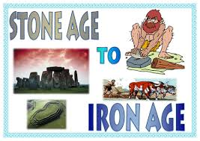

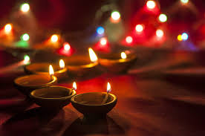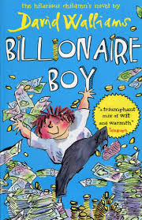

**As design technologists we will…**

Design and create our own healthy lunch menus focussing on nutrition.

Let Your Spirit Fly. The material presents an integrated approach to music where games, the dimensions of music (pulse, rhythm, pitch etc), singing and playing instruments are all linked.Learning about different instruments with a

**As an artist we will be…**

* Practicing our sketching skills by focussing on light and dark and creating images of shadow using hatching and cross-hatching.

**As a mathematician we will be…**

* Adding and subtracting two and three digit numbers.
* Extending our knowledge of multiplication tables.
* Begin learning how to multiply and divide using formal written methods.

**In Religious Education, we will be…**

Learning about different festivals of light across the world and how they are celebrated in a range of religions

**As a scientist we will be…**

* Learning what nutrition our body needs to survive.
* Exploring how our skeleton works.
* Finding out what our skeleton protects.
* Naming important bones in our body.

**As a musician we will be…**

Listening to a range of instruments and learning about the art of music from a professional teacher.

Let Your Spirit Fly. The material presents an integrated approach to music where games, the dimensions of music (pulse, rhythm, pitch etc), singing and playing instruments are all linked.Learning about different instruments with a

**As a Historian we will…**

Be comparing buildings, conflict, rich and poor, beliefs and transport and trade across the periods of the Stone Age, Bronze Age and Iron Age. We will also be locating some key places on maps of the UK.