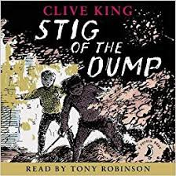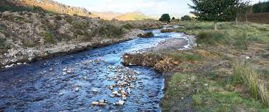

**Year 3 Spring Term 1**

**As a reader we will be…**

* Listening to the story ‘Stig of the Dump’ by Clive Davis and unpicking the meaning behind it to improve our comprehension skills.

**As Geographers we will be…**

* Locating and identifying the countries, cities and human and physical features of the UK.
* Look at some of the UK’s most famous buildings, castles and monasteries.
* Understand how a

river flows from source

to mouth.

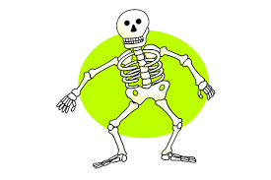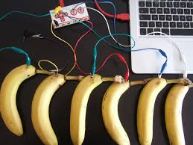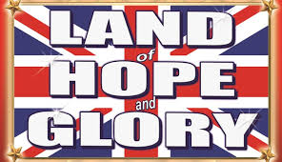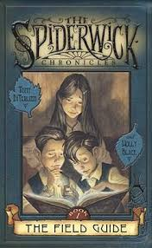

**As a musician we will be…**

Listening to a range of instruments and learning about the art of music from a professional teacher.

Let Your Spirit Fly. The material presents an integrated approach to music where games, the dimensions of music (pulse, rhythm, pitch etc), singing and playing instruments are all linked.Learning about different instruments with a

**In Religious Education, we will …**

Learn about what different people believe that God is like and observe various interpretations.

**As a Writers we will…**

Discover a world of wonderful mythical creatures in our book as a hook, ‘The Spiderwick Chronicles’, by Holly Black and Tony Diterlizzi. We will…

* Create our own fictional story characters,
* Invent our own mythical creatures,
* Write explanation texts about the amazing creatures we meet,
* Interview our story characters and tell the story from their point of view.

**As design technologists we will…**

Design and create our own banana and fruit keyboard using a Makey Makey kit!

Let Your Spirit Fly. The material presents an integrated approach to music where games, the dimensions of music (pulse, rhythm, pitch etc), singing and playing instruments are all linked.Learning about different instruments with a

**As an artist we will be…**

Print using a variety of materials, objects and techniques including layering.

Explore pattern and shape, creating designs for printing.

**As a mathematician we will be…**

* Extending our knowledge of multiplication tables.
* Learn how to multiply and divide using groups.
* Begin learning how to multiply and divide using formal written methods.

**As a scientist we will be continuing…**

* Learning what nutrition our body needs to survive.
* Exploring how our skeleton works.
* Finding out what our skeleton protects.
* Naming important bones in our body.