**As Historians we will**

Look at how transport and trade has changed over time, focusing firstly on modern day transport around the world and then expanding our search to include an in depth look at how transport and trade was similar and different in Roman Times.

We will consider the impact of the growth of The Roman Empire on British transport and trade.

We will use a variety of sources to explore historic times and consider what sources tell us the most about the past.

**As Scientists we will**

Building on our prior knowledge of vertebrates and invertebrates

Classifying animals based on whether they are vertebrates or invertebrates

Using classification grids to explore the characteristics of different groups of vertebrates and invertebrates and compare similarities and differences

Discovering the impact that humans have on the environment and how these changes can effect animals and their habitats

**In R.E we will be**

Looking at the question *‘Can religious rules teach us how to live’.* We will explore the Ten Commandments and the impact they have for both Christians and Jewish followers

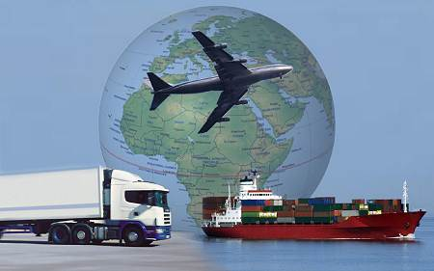

**As Mathematicians we will**

We will be looking at place value using 4-digit numbers up to 10,000

We will use our knowledge to reason and problem solve

**As Musicians we will be**

Learning how to play the Samba drums and also learning to analyse musical compositions as well as learning to sing an African song.

Transport and Trade

**As Artists we will**

Take inspiration from the artist Vincent Van Gogh to sketch, draw and paint our own transport masterpieces

**As writers and readers**

We will be writing our own play scripts based on The BFG

We will then continue to focus on the work of Roald Dahl by looking at his Revolting Rhymes and using these to inspire us to write our own revolting rhyme based on the story of The Three Little Pigs

We will be reading Kensuke’s Kingdom by Michael Morpurgo in preparation for our writing in Autumn 2

**In Computing we will be**

Developing our own educational games using Scratch

**In P.E we will**

Develop our skills in Dance by taking inspiration from The Egyptians and Mauri tribes

**As Designers we will**

Construct a Dhow inspired by the Vikings.