**As Geographers we will**

Taking an in depth look at some of the most famous landmarks in Europe. We will locate them on a map and begin to explore why they are famous and what similarities and differences we can find between some of these buildings.

We will also look at the historical significance of these buildings- including their roles in culture, religion and tourism.

**As Scientists we will**

Learning about states of matter. We will be looking at solids, liquids and gases and the scientific processes that occur to change a materials state of matter.

We will be visited by King Fisher Education who will deliver a water workshop in which children will learn about the water cycle and water conservation.

**In R.E we will be**

We will be looking at the creation story and creation stories both secular and non-secular. We will then consider what message these stories give us about the world that we live in and our duty as a responsible citizen.

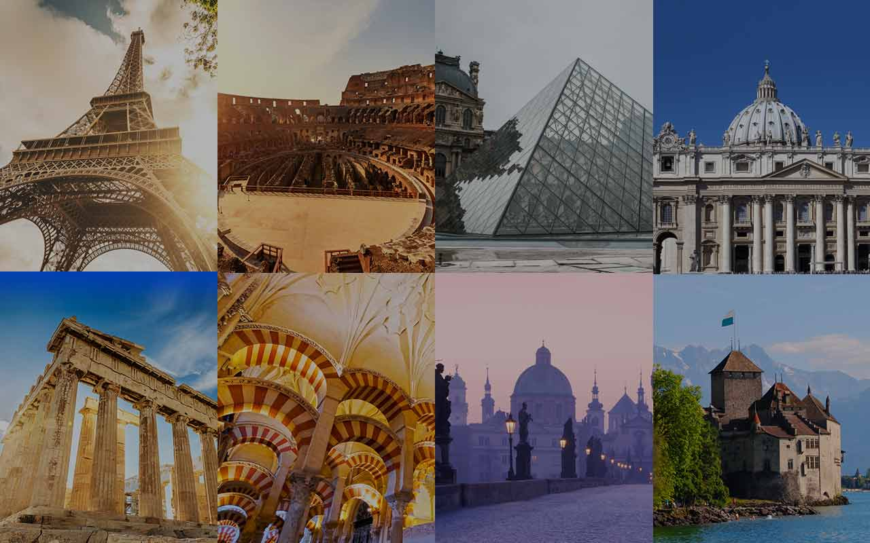

**As Mathematicians we will**

We will be learning to multiply and divide and recall key times table facts to do this efficiently.

We will begin to look at fractions, revisiting prior learning and applying this to gain a deeper understanding

Finally we will look at decimal numbers

**As Musicians we will be**

We will learn how to play the djembe drums. These are percussion instruments that children will learn to play using only their hands to create different rhythms and sounds.

**Eurovision**

**As Artists we will**

Take inspiration from The Romans by creating our own Mosaics. We will also take a look at how mosaic art has changed over time by looking at the work of modern day artists.

**As writers and readers**

We will be using the picture book ‘The Man on the Moon’ to write character descriptions, setting descriptions, diary entries, comic strips, adventure stories and leaflets.

We will continue to have communication lessons using the book ‘Letters from the Lighthouse’ as our comprehension text.

We will be learning about fronted adverbials, dialogue, subordinate clauses and prepositional phrases.

**In Computing we will be**

Using digital software to create music for meditation and relaxation

**As Designers we will**

Design and make a water butt to collect water to reuse.

**In P.E we will be**

Demonstrating our catching and throwing skills, and practising attacking and defending skills to slowly progress towards playing competitive games of rugby