**As a writer we will be…**

**Writing a non-chronological report about the rainforest.**

**As a mathematician we will be…**

Solving multi-step word problems involving multiplication and division.

Year 5

Spring Term

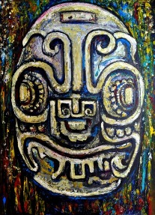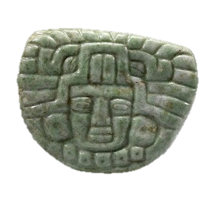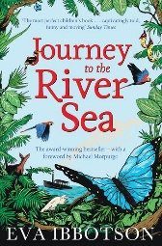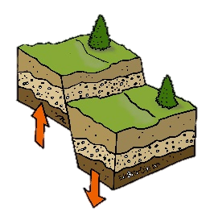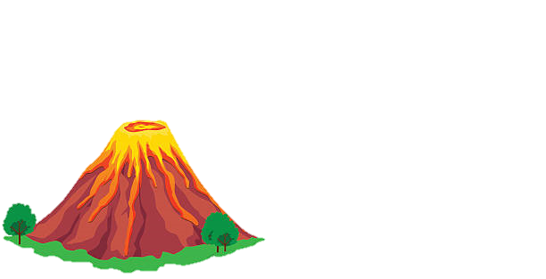

**As an artist we will be…**

**Creating sculptures taking inspiration from ancient Mayan art.**

**As a geographer we will…**

* Locating volcanoes in North and South America.
* Exploring how volcanoes occur.
* Be describing the geographical diversity.
* Be understanding similarities and differences through the study of human and physical geography of Mexico.

Earthquakes and volcanoes

**As a reader we will be…**

* Reading the novel ‘Journey to the River Sea by Eva Ibbotson.

**As designers we will be exploring…**

* The use of levers and creating movements using a pivot point.
* Finding out about simple machines, like a catapult.

**As scientist we will be…**

* Comparing and grouping materials based on their properties.
* Describing how mixtures might be separated.
* Demonstrating reversible and irreversible changes.