Year 5

Autumn term 1

**As a mathematician we will be…**

* Reading and writing numbers to 1, 000,000.
* Comparing numbers to 1, 000,000.

**As a writer we will be…**

* **Writing a new chapter to Carrie’s War.**
* **Using expanded noun phrases, fronted adverbials and prepositions.**

Rich and poor

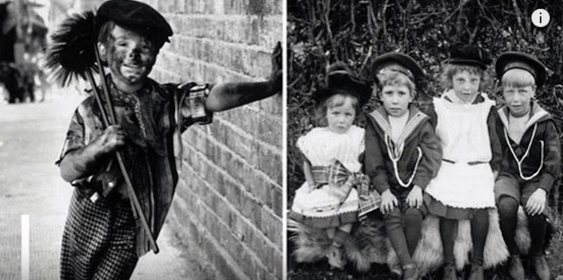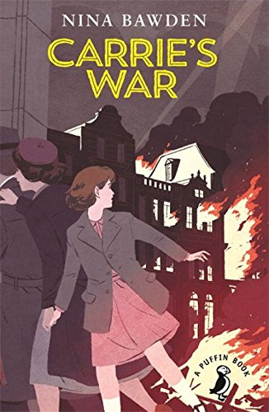

**As a reader we will be…**

* Identifying grammar features Nina Bawden uses to write an adventure story.

**As a historian we will…**

* Studying the differences in the lives of rich and poor throughout British history.
* Exploring the differences between rich and poor in some ancient civilizations, for example Ancient Greece, The Shang Dynasty.

**As an artist we will be…**

* Taking inspiration from Rosalind Monks to draw correctly proportioned insects in their environment/.
* Showing appropriate shadows using cross hatching and blending.

**As a scientist we will be…**

* Observing and comparing the lifecycles of animals in their habitats.
* Finding out about reproduction of animals and plants.

**As designers we will be exploring…**

* The use of axles and wheels in vehicles.
* The use of levers and creating movements using a pivot point.
* Finding out about simple machines, like a catapult.