Science Science this half term will focus on ‘Living things and their Habitats.’ We will look into how and why animals are classified into different groups and explore the work of scientists who have worked in this area.

RE

‘Why, where and how do Hindus worship?’

In RE we will enquire and explore the concept of worship in Hinduism.

Computing

‘We are Adventure Gamers’

This half term the children will be creating their own text-based adventure game. They will use commands, and write and debug programmes as they progress from Scratch.

Year 6

Autumn 1

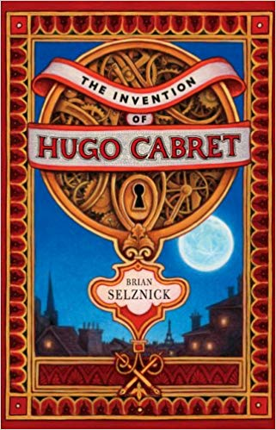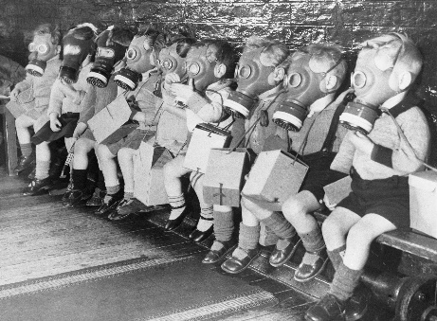

English The Invention of Hugo Cabret Brian Selznick

We will continue our English curriculum with a ‘Book as a Hook.’

Our first book this year is Hugo Cabret. We will use this to write diary entries, monologues and newspaper reports.

Creative Curriculum

World War II

In Creative curriculum we will be: investigating and interpreting the past; understanding chronology and where World War II fits into history; building an overview of world history and communicating historically (using appropriate historical vocabulary and presenting ideas). We will delve into World War II exploring how life was for different people in those times.

PE

The children will participate in two PE lessons a week with myself and Elite coaches. This half term the focus is dance.

Maths

This half term we will be looking at the place value of digits up to millions, negative numbers and the four operations: addition, subtraction, division and multiplication. We will continue to use fluency, reasoning and problem solving to answer questions on this in preparation for SATs and will be continuing to work on our arithmetic skills.