Science Science this half term will focus on ‘Animals including humans.’ We will look into the circulatory system describing the functions of the heart, blood vessels and blood. We will also explore our diets and how our bodies can be affected by our life style choices.

Computing

‘We are computational thinkers’

We will be exploring algorithms looking at how Maths is used in online programmes such as scratch and snap.

RE

‘Can religions help to build a fair world?’ We will be looking at the Christian value of fairness; how it looks around the world and how different religions work to help those in need.

PE

The children will participate in two PE lessons a week with myself and Elite coaches. This half term the focus is basketball.

Year 6

Autumn 2

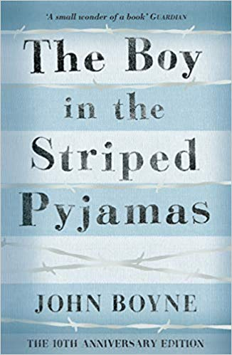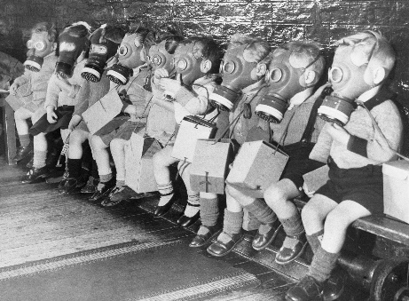

PSHE

We will have four visits this half term from HH kids to discuss puberty and growing up. We will also explore relationships as part of this.

Maths

This half term we will be exploring fractions. We will look at the different operations within this. We will also look at coordinates on a grid and how to translate shapes; alongside this, we will continue our arithmetic skills.

Creative Curriculum

World War II continued

In Creative curriculum we will be: investigating and interpreting the past; understanding chronology and where World War II fits into history; building an overview of world history and communicating historically (using appropriate historical vocabulary and presenting ideas). We will delve into World War II exploring how life was for different people in those times.

English The Boy in the Striped Pyjamas John Boyne

This book links to our creative curriculum topic and allows us to delve into life in WWII further. We will take on the role of the characters and write diary entries, monologues, and non-chronological reports. We will continue with a separate grammar lesson to brush up on our comprehension, spelling and grammar skills.