PE

The children will participate in two PE lessons a week with myself and Elite coaches. This half term the focus is football.

Science This half term we will continue our focus on the circulatory system describing the functions of the heart, blood vessels and blood. We will also explore our diets and how our bodies can be affected by our life style choices.

Computing

‘We are Advertisers’

Year 6 are going to be using Imovie to create their own advert looking at frames, lighting, sound and how to edit their movies.

Year 6

Spring 1

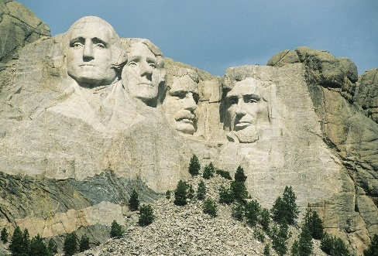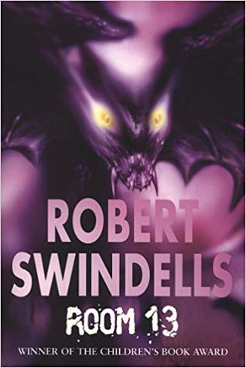

RE

‘How are faith communities represented in the UK?’ We will be looking into the diversity of religion across the UK. We will look at our shared values and our differences and we will explore the challenges that can be present.

Maths

This half term we will be exploring decimals, percentages and algebra and how these can be equal to eachother.

Creative Curriculum

Land of the Free

In Creative curriculum we will be exploring America. We will look at the physical features such as the National parks, rockies, active volcanoes and Tornado Alley. We will also look at the human features such as the skyscrapers and monuments. We will study American pop artists such as Andy Warhol and Roy Lichtenstein and look at bridges in D&T.

English Room 13 Robert Swindells

We will:

-write character and setting descriptions

-letters from the character’s perspective

- write a narrative

-write a diary extract

-write a dialogue between two characters