**Personal, Social and Emotional Development**

* Getting to know each other and sharing our learning environment
* Introducing our new routine, behavioural expectations; welcoming and valuing praise
* How to make new friends; invitations to play; friendly behaviours, showing care and concern for others
* Circle time talking about their home and community; All about me (I like …, I live with …, My family are …)
* Supporting transition; spending time to build relationships with each child so they feel safe and secure

**Communication and language**

* General classroom rules: following simple instructions
* Listen with interest to short stories 1:1 or in small groups
* Role play- Home corner and house of the 3 little pigs
* Building confidence in talking in small groups together, sharing our ideas and taking turns in speaking and listening to others
* Encouraging and modelling talking in sentences

**Physical Development**

* Exploring the new indoor and outdoor environments
* Run skilfully showing control when adjusting speed or direction to avoid obstacles
* Choosing own healthy snack; pouring their own drinks; managing personal hygiene; hand washing and toileting
* Using mark making tools using one hand to draw lines & circles/write and express their ideas.

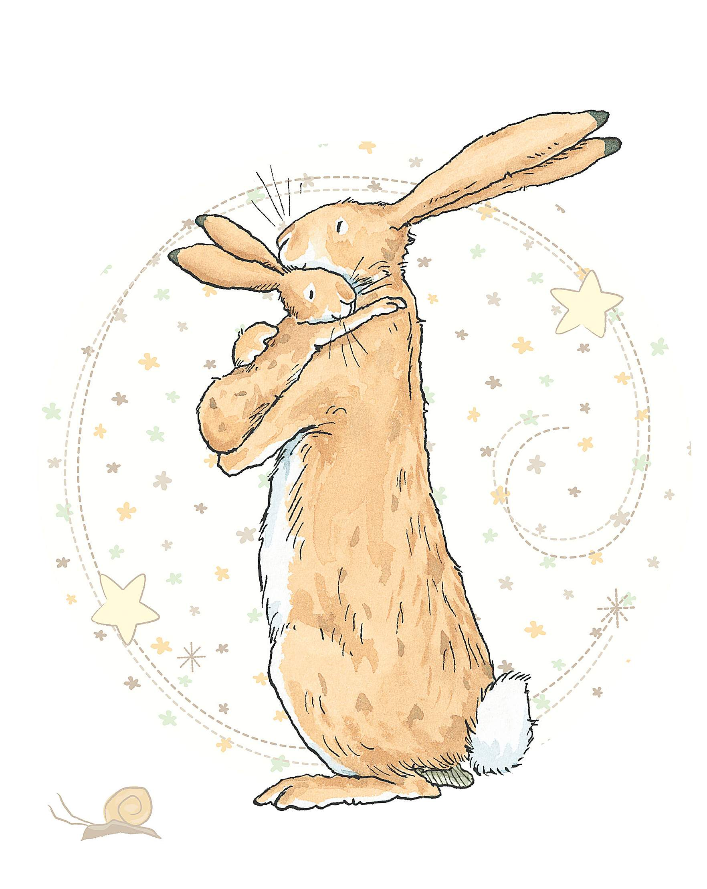 Why do you love me so much? Nursery Autumn 1 2018

A warm welcome to our children and their families, particularly those new to our Bedford Hall School family! This is the first newsletter of six which you will receive at the beginning of each half term. This will give you an overview of what we plan to explore and learn over the next half term and skills we be focussing on developing. As ever we do this alongside the knowledge we gain from the children to ensure we follow their interests too. We welcome you sharing your child’s learning and experiences they enjoy outside of school too and you can do this via Tapestry or by completing a WOW moments sheet (just ask at the door) or sending in photos and notes from home.

Please remember to label all items of clothing and provide nursery with at least one spare set of clothes. Snack is £1 a week or £6 for this first half term, please pay direct to nursery staff.

We are encouraging families to pre order your child’s lunch online at home via Lunchshop website- details at the school office.

If you have any questions please do not hesitate to ask. Thank you Mrs Nixon Mrs Taylor & Miss Merga

**Literacy**

* Showing interest in text in the environment; ascribing meaning to marks they makes/see
* Handling books and beginning to listen to and join in with songs and stories
* Stories with a theme of families, friendship, love and favourite bedtime stories
* Listening to sounds in the world around us

**Understanding the World**

* Shows a sense of own family and relations; using names, talking about their memories and experiences in role play from
* Explores the small world resources to develop their own narratives
* Begin to notices changes in the world around and discover the traditions around Harvest festival.

Expressive Arts and Design

* Make music to match the world around us
* Create mini beast dances and masks
* Work in clay and then in paint to make mini beasts
* Sketching real life
* Making tall sunflowers and beanstalks (adapting work to support more height)

Mathematics

* Daily counting on and back from a given number
* More/less bingo & mini beast/ fruit and veg. addition and subtraction- model counting on and back
* Problem solving within cooking
* Dragonfly patterns
* Measuring distance in the ant maze
* Measuring the height of growing plants and record

**Expressive Arts and Design**

* Joining in with others singing rhymes & songs.
* Experimenting with colour and mark making tools; paint, chalk, pencils, crayons.
* Using role play to recreate real life experiences, making props for role play (T.V., baby’s bottles etc.) Adults model real life scenarios for the children to take up and continue.

**Mathematics**

* Join in with number songs and rhymes
* Noticing quantities of objects and beginning to make comparisons; more/a lot/less
* Counting objects using number names to identify how many objects are in a set ; counting out a set of people to make little families and groups of friends
* Become familiar with the new routines and responds to this by showing awareness of preparation needed at tidy up time/lunch/home time