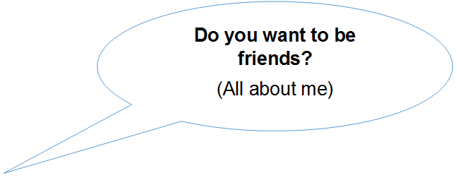
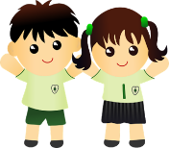
Reception Curriculum Newsletter
A warm welcome to Bedford Hall Methodist School, we look forward to working with you and your child throughout the year.
This half term in Reception we are focusing on the topic ‘Do you want to be friends?’, through looking at ‘All about Me’.
During the first week we will be learning routines, getting to know each other, and creating portraits of ourselves.
As the half term moves on we will be working on:
Communication and Language – Developing our speaking and listening skills through circle time activities, listening to stories involving families and our bodies. Developing our ability to ask questions, through sense investigations and observing our bodies and noting how they are the same and different to each other.
Physical Development – Starting P.E. skills, with dressing and undressing. Working on how our bodies can move in different ways. Developing our writing skills by working our whole bodies, down to small movement in making split pin people.
Personal, Social and Emotional Development – Looking at emotions and how they affect our mood. Developing ways of playing with our friends, solving problems and finding ways to resolve conflict. We will have circle time sessions, where we will be discussing our feelings.
Literacy – We will be starting to use Read, Write, Inc to learn our letter sounds and begin to write them too. The children will also start to read and write simple words and captions. We will be reading a range of books involving families and feelings, as well as reading labels to do with the body.
Maths – We will be developing our counting skills through counting games, such as a body part dice game. We will use 2D shapes to create models of houses and people, while naming the shapes with mathematical language.
Understanding the World – We will be focusing on our similarities and differences, through Family stories, and footprint textures. We will be looking at our family and who is in our family, and how we have changed over time. To record our emotions we will be using the iPad to take photos of our emotions.
Art and Design – We will be using our observational skills to draw our faces, and then choose the correct colours for our hair, eyes and skin. Over the half term we will look at textures, our finger prints, as well as developing our singing skills and knowledge of instruments, including body percussion.

Don’t Forget – Bring coats everyday - Snack money is £1 per week - You can order lunch on-line - Ensure P.E. kits are in school

