Reading Reminder

Children should try to read at home 3 times a week, they will receive a dojo each time they read.

Welcome to Year 3!

PE

Children will be going swimming on a Monday afternoon and they will have a session with the Elite coach on Thursdays.

English

Wings of Icarus By Jenny Oldfield

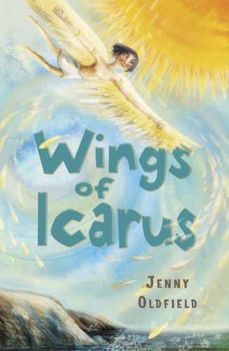

*This term the genre of writing may include:*

Instructions

Recount

Story Endings

Character Descriptions

Letter

Information Texts

*Punctuation and Grammar:*

Capital letters, full stops, question marks and exclamation marks

Prepositions

Headings and sub-headings

Conjunctions

Present and past tense

Mathematics

We have started our Year 3 Maths No Problem this week. The children will focus on the place value of numbers up to 1000. They will also learn how to write them in both numbers and in words. They will go on to comparing and ordering these numbers and count in 4’s, 8’s 50’s and 100’s. We will then move onto addition and subtraction using formal written methods.

Please practice times tables regularly with your child.

Creative Curriculum

This term our topic is Gods & Mortals. The children will be learning all about Ancient Greece including mythical creatures and legendary heroes such as Poseidon, Apollo and Zeus. They will be using their geography skills to explore the terrains of Greece in ancient and modern times. Their history skills will be used to look at the chronological order of events and dates then place them on a timeline.

Computing

We will start the year by looking at basic programming and coding.

RE

The term the children will learn about different sacred and holy books. They will explore different stories within the Bible, Sacred Texts and other Holy Books.