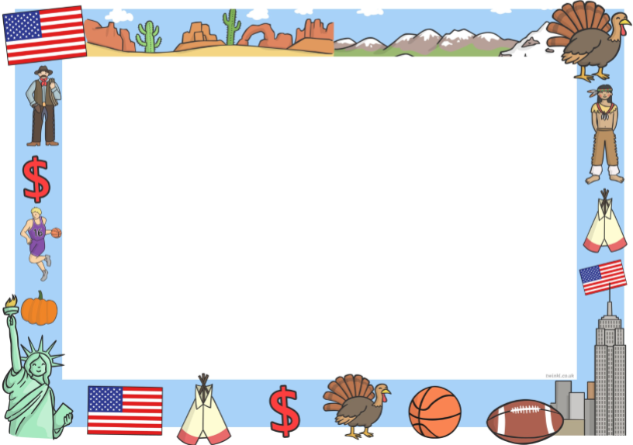 **Road Trip USA! Year 4 Term 2**

**Mathematics**

In Maths pupils will learn to count in multiples of 25, 100 and 1000 in order to count larger numbers comprehensively. They will learn about the relative size of numbers and complete number sequences within 10 000. Pupils will learn about place value to 4 digits and they will link numbers in numerals and in words. They will compare numbers using language such as 'greater', 'smaller', 'less' and 'more', using the mathematical symbols <, > and =. They will use their knowledge of number and place value to help complete number patterns. They will also learn about rounding numbers to the nearest 1000, 100 and 10; children will apply this knowledge to approximate, total and find the difference.

**English - Book – I want my hat back**

In English we will continue to develop our skills of description. We will be describing characters and settings in detail. We will look at the power of persuasion and create numerous genres of work such as; - Full Narrative - Character description -Information texts

**Punctuation & Grammar**

We will develop our use of direct speech, conjunctions, fronted adverbials, apostrophes and spelling patterns

**RE**

In R.E. we will be focusing on the question ‘Can religious teachings help us decide the best way to live? ‘

**Music**

In Music the children will continue to work with our music teacher to develop their skills.

**Science**

In Science we will identify common appliances that run on electricity. Pupils will identify whether or not a lamp in a simple circuit will light. They will construct a simple series of electrical circuits and identify the parts of a circuit.

**Art and design**

This term children will improve their mastery of art and design techniques, including drawing, painting and sculpture with a range of materials.

**History**

The children will learn about the history of the USA. Pupils will look for comparisons between the USA and the UK. They will also learn all about Native Americans.

**PE**

This term the children will be working with a Sports Coach from Premier Sports as well as looking at their team skills.

**Geography**

Children will use maps, atlases, globes and digital/computer mapping to locate and describe features of the USA. They will describe and understand key aspects of the physical geography of the USA e.g. climate zones , mounatins , rivers etc. Pupils will also undersatnd key aspects of human geography including types of settelements, economic activity and the distribution of natural resources.

