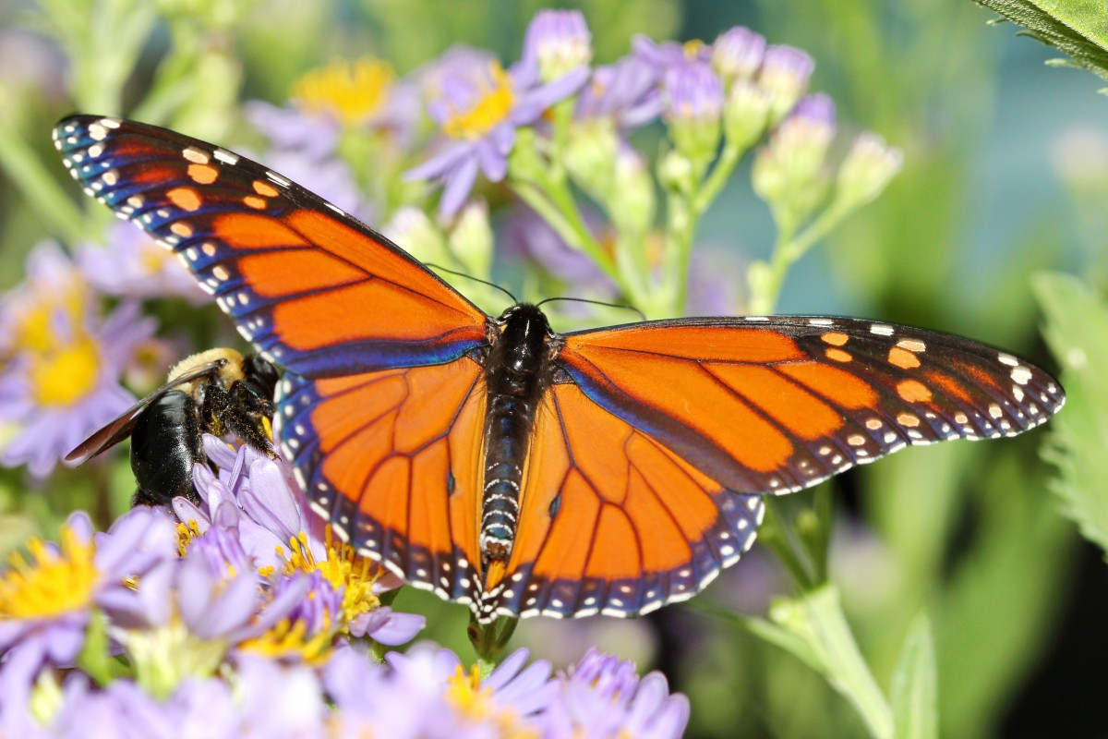

Home Learning

This half term we would like you to participate in a home learning activity.

Activity

To create a home for and write a fact file for a chosen mini-beast.

To be in school by:

20.5.19

EAD

We will be designing and then making a hand puppet mini-beast, sing a variety of different techniques.

We will also be exploring dance and movement using our own music and provided music.

Literacy

We will be reading the story of Christopher’s Caterpillars and using this as a stimulus to create descriptive lost posters and lists, before writing a simplified version of the story.

We will then read the non-fiction book Things with Wings and create fact files, suing the internet to help us answer questions.

Things with wings

This half term we will be learning about caterpillars and their transformation, as well as exploring other animals that have wings.

Maths

We will be focusing on our pattern skills, addition and subtraction using a number line, capacity, 3D shape and doubles.

UtW

We will be finding out about the caterpillar life cycle, using the internet for research, discovering the stories Jesus told, and learning about the festival of Ramadan

PD

We will be continuing our work with our P.E. on athletics, as well as exploring dance linked to the Hungry Caterpillar

We will be developing our safety skills while creating our mini-beast hand puppet.

CLL

We will be rehearsing our sentences before writing, as well as thinking about and explaining our knowledge of caterpillar metamorphosis. We will be asking and answering questions posed by our things with wings topic.

PSED

We will be working on our abilities to play games, taking into account others ideas, e.g. discussing ways we can solve conflicts. We will also start to play games with fixed rules, e.g. snakes and ladders.

Important Messages

* Snack money - £1 per week payable on a Monday
* P.E. kit to be in school at all times
* Ensure all clothing is named
* Continue to read each night
* Update Tapestry with any WOW moments that your child may have.