be

**Mathematics**

In Maths we will begin to learn about fractions, including finding fractions of shapes and amounts. We will also begin to learn about time, including recognising o’clock, quarter past, half past and quarter to on an analogue clock. Additionally, we will learn how to count in 5s to recognise 5 minute intervals on a clock and write these. We will also begin to recap all the maths knowledge we have learnt so far so that it is fresh in our memories for SATs next half term.

**English**

We will be basing our English work around a picture book every half term and this term our focus is ‘Biscuit Bear’. We will be writing missing posters, character descriptions, narratives, letters and diary entries and will be focussing on improving our sentences through a range of vocabulary and punctuation. We will also continue with our spelling and grammar work and comprehension skills by focussing on a range of inference and deduction questions.

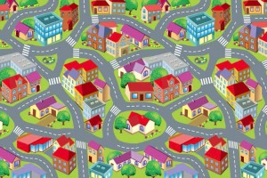

**Creative Curriculum**

This half term we will be basing our work around the topic ‘Street Detectives’. We will start off with an investigation by exploring pictures of Leigh in the past and present and identifying the differences. We will be identifying physical and human features in our local area and in the UK, recreating maps of our local area and designing our own dream local areas. We will also begin to learn about houses and homes, including the different types of homes in our local area and identifying how houses have changed. We will learn about a famous artist called Claude Monet, including discussing our likes and dislikes, sketching based on his painting style and painting our own. We will continue this topic after half term.

**Street Detectives – Year 2 Spring 2**

**PE**

We will be focussing on multi-skills and yoga this half term. PE will be on Wednesday and Friday. Please ensure that your child’s PE kit is always in school on these days.

**Computing**

We will be learn how the internet can be a useful tool for research and learn the importance of staying safe whilst exploring the internet and using technology.