Don’t forget the 200 million minutes reading challenge!

Homework

Children should try to read 3 times a week and have an adult sign their planner. Children should also practise spellings and 3, 4 and 8 times tables as we work on this weekly within school. (Just a reminder children are expected to know all their times tables by the end of year 4)

RE

In RE this term the children are going to be exploring Easter and the parts of it that matter to Christians.

Year 3

Spring 2

Creative Curriculum

This term our topic i

This term there will be a big focus on our new topic Tremors. We will be looking at how to design and building or bridge to withstand an earthquake. We will be taking a closer look at natural disasters specifically volcanic eruptions, earthquakes and tsunamis. In History we will be researching Mount Vesuvius and Pompeii.

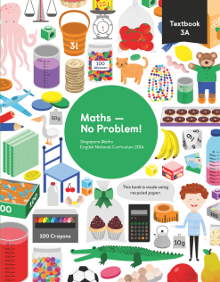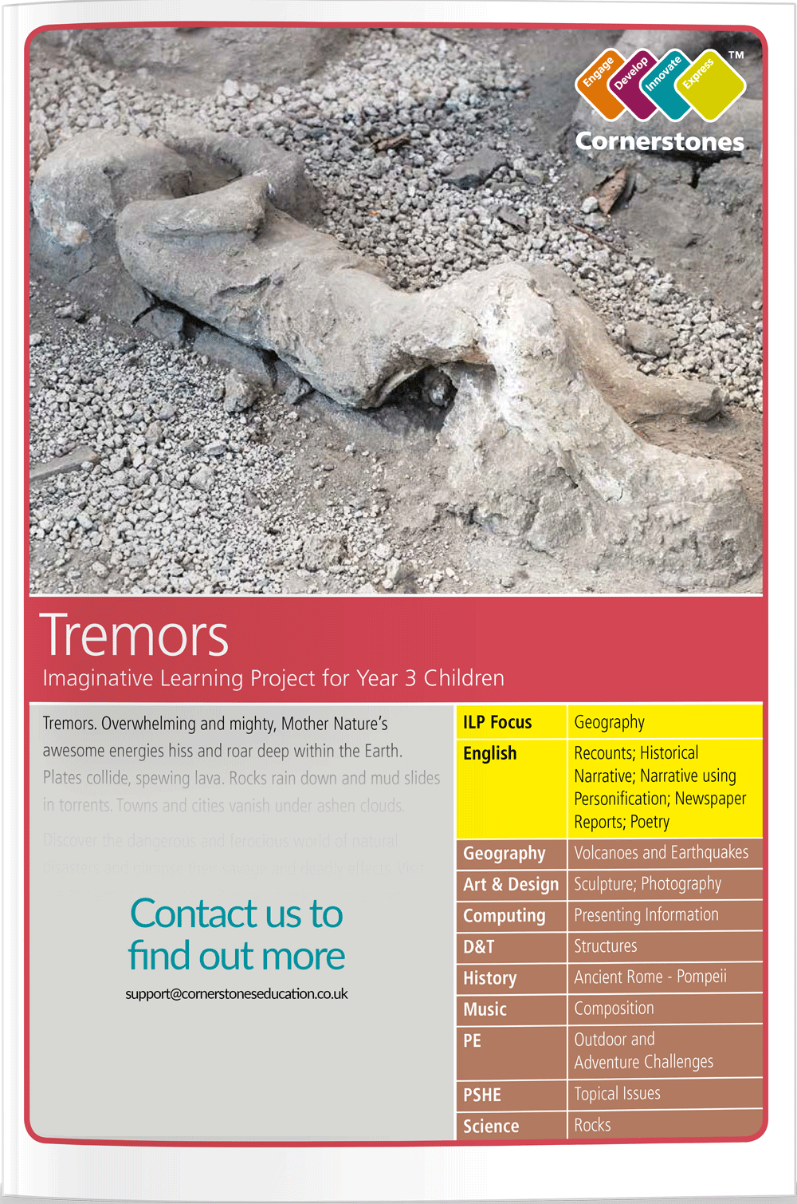

PE

The children will participate in two PE lessons a week – one with Elite coaches.

Mathematics

This term we will be continuing our work on time and fractions as well as keep practising our times tables and calculations skills.

English

Escape from Pompeii

By Christina Balit

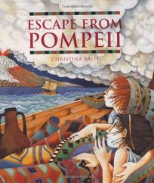

We will continue to develop our writing skills within our English. Focusing on fronted adverbials, apostrophes, conjunctions, spelling rules and comprehension skills.