be

**Mathematics**

In Maths we will be learning more about time, including recognising o’clock, quarter past, half past and quarter to on an analogue clock. Additionally, we will learn how to count in 5s to recognise 5 minute intervals on a clock and write these. We will link our knowledge of time and fractions to learning about position and direction, including full turns, quarter turns and half turns clockwise and anti-clockwise. We will also continue to recap all the maths knowledge we have learnt so far so that it is fresh in our memories for SATs this half term.

**English**

We will be basing our English work around a picture book every half term and this term our focus is ‘Into the Forest’. We will be writing information texts, character descriptions, narratives, poems and letters and will be focussing on improving our sentences by using conjunctions and up levelling our vocabulary. We will also continue with our spelling and grammar work and comprehension skills by focussing on a range of inference and deduction questions.

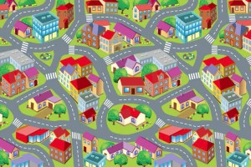

**Street Detectives – Year 2 Summer 1**

**Creative Curriculum**

This half term we will be continuing our work around the topic ‘Street Detectives’. We will learn more about the history and geography of our local area and will use this to be innovative and design our own local areas, thinking about buildings, leisure facilities, statues, local events, etc. We will also be identifying people that help us in our local area and will be thinking about the ways that they help. We will take part in some role play situations based on this.

**PE**

We will be focussing on striking and fielding games this half term. We are also lucky to have a visitor from Healthy Lifestyles teaching us on Friday’s. PE will be on Wednesday and Friday. Please ensure that your child’s PE kit is always in school on these days.

**Computing**

We will be learn all about email, including how to open, reply to and send emails. We will also be thinking about their purpose and how emails can be purposeful. Furthermore, we will refer back to online safety and discuss the potential dangers of using email and what we can do to keep safe.