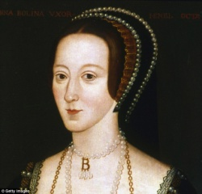
question ‘Why is Easter important to Christians?’ in our RE lessons.
Art – we will be looking at the work of Giuseppe Arcimboldo
DT – we will be evaluating, designing and creating our own Tudor pouches

Winmarleigh Hall!

This half term Y5 go on their residential trip to Winmarleigh Hall.
RE:
This half term our big question is:
Why do believers see life as a journey?
Science
In science our topic is all about Materials. We will be carrying out a range of experiments throughout the topic to investigate the properties and changes of different materials.
Mathematics
Angles
We will working on the skills of measuring and drawing angles using a protractor and also solving angle problems using out knowledge of angles on a straight line and angles around a point.

Position and movement
We will be looking at the translations and reflections of shapes, using grid lines and reading coordinates.

Year 5: Summer 1
Off with her head!
(Continued)
Creative Curriculum
Travel back in time to the 1500s and meet the terrifying Tudors! Children will discover how the Tudors fit into our history, looking at the Tudor family tree and the reign of each monarch. We will investigate the life of Henry VIII and his wives and learn about different Tudor crime and punishments. We will also look at Tudor portraits and artwork, creating our own royal paintings.
English
This half term we will be continuing to read William Shakespeare’s ‘Hamlet’. Children will be given numerous writing opportunities, which will cover a range of genres such as; biographies, persuasive writing, playscripts, newspaper reports and narratives. Handwriting and SPaG sessions will be taught daily as well as comprehension and communication sessions that will give pupils the opportunity to develop their language skills.

