Science – Plants

We will be looking at the different parts of a plant and labelling them as well as understanding what job they do. The children will also investigate how water travels through a plant.

Homework

Children should try to read 3 times a week and have an adult sign their planner. Children should also practise spellings and 3, 4 and 8 times tables (including division facts) as we work on this weekly within school. (Reminder - children are expected to know all their times tables by the end of year 4).

RE

In RE this term the children are going to be exploring what worship is and why it is important to believers and understand the main features of Christian worship.

Year 3

Summer 1

Creative Curriculum

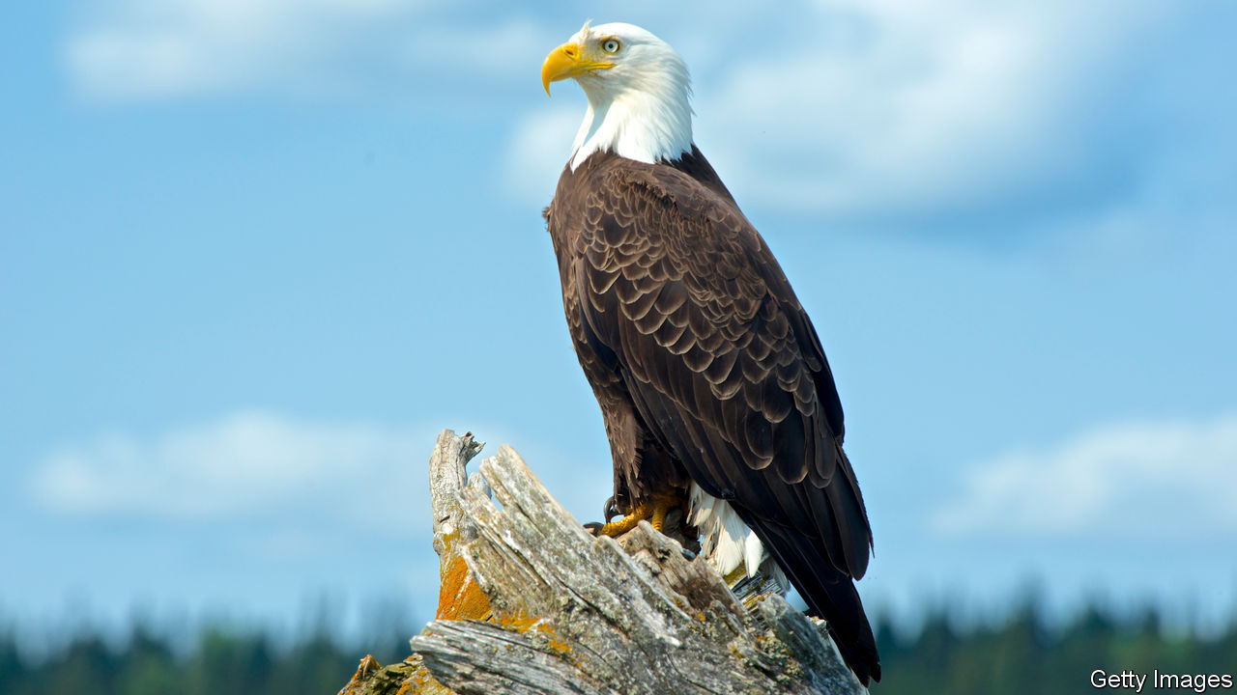

This term our new topic is Predator!. We will be looking at the different habitats of predators including crocodiles and sharks as well as looking at how the environment supports their needs. We will also be looking at the difference between parasites and predators and food chains.

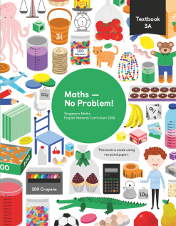

PE

The children will participate in two PE lessons a week – one with Elite coaches.

Mathematics

This term we will be continuing our work on fractions and looking at angles, lines & shapes and perimeter of figures.

English

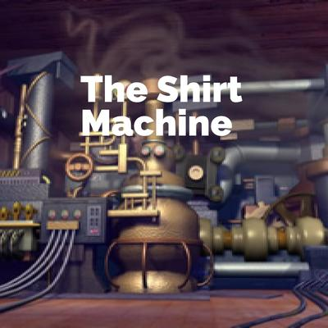

Video Clip – The Shirt Machine

By Jon Davis

We will continue to develop our writing skills within our English focusing on different types of questions, converting them into dialogue using accurate punctuations and using description to write an explanation of a shirt design and our own machines.