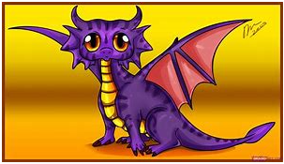

Maths

We will be focusing on our addition and subtraction skills, counting in a range of ways, and revising our shape and measurement skills.

EAD

We will be exploring a range of materials to create houses, and using our adaption skills to make changes when necessary.

We will continue to learn new songs and dances.

Home Learning

This half term we would like you to participate in a home learning activity.

Activity

To create a map of your journey to school. (This can take any form, e.g. model, written, movie, etc).

To be in school by:

8.7.19

UtW

We will be exploring our local environment. Finding out about the different houses in our local area and comparing to those in other countries. We will continue to IT for a purpose, and learn more about Christianity.

.

Literacy

We will be reading the story of There is No Dragon in This Story, and using it as a stimulus for our story writing.

We will then read the non-fiction book Komodo Dragons, and find out more information about real dragons in our world. We will use the internet to find out more information and use what we have learnt to create fact cards.

There is no dragon in this story!

This half term we will be learning about narrative writing, and the environment that we live in.

PD

We will be continuing our work with our P.E. on athletics, as well as practising for sports day.

We will continue to work on using tools and putting things away safely.

CLL

We will be rehearsing our sentences before writing, as well as thinking about how stories are formed, what the characters and settings look like, how every story has a problem that needs solving and a good ending.

PSED

We will be working on our abilities to play games, taking into account others ideas, e.g. discussing ways we can solve conflicts. We will also start to play games with fixed rules, e.g. snakes and ladders.

Important Messages

* Snack money - £1 per week payable on a Monday
* P.E. kit to be in school at all times
* Ensure all clothing is named
* Continue to read each night
* Update Tapestry with any WOW moments that your child may have.