be

**Mathematics**

In Maths we will begin to look at different ways of sharing, including sharing and grouping before learning about division by 2, 5 and 10 using practical and mental strategies. We will be linking this to our work on multiplication and will investigate the relationship between multiplication and division and odd and even numbers. We will then move onto learning about length. Children will get a better understanding of how to measure length and will understood what a metre and centimetres are, before applying this to real-life contexts.

**English**

We will be basing our English work around a picture book every half term and this term our focus is ‘The True story of the three little pigs’. We will be writing information texts, diaries, glossaries, fairy tales and riddles and will be focussing on improving our sentences through a range of vocabulary and punctuation. We will also continue with our spelling and grammar work and comprehension skills by focussing on a range of inference and deduction questions.

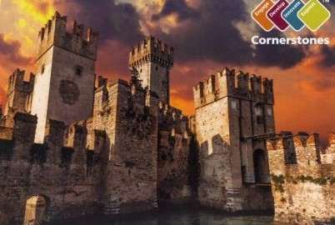 **Towers, Tunnels and Turrets – Year 2**

**Creative Curriculum**

This half term we will be basing our work around the topic ‘Towers, Tunnels and Turrets’ which has a castle theme. We will learn about the features of different castles and find out about how castles have changed through the ages. We will be investigating the strength of materials by building a castle wall and testing which materials can knock it down. We will then design and make our own catapult and test these out. In Geography, we will be looking at famous structures and towers around the world and will find these on a map and draw our own. In History, we will find out British monarchs, the role of a monarch and will be comparing different monarchs such as Queen Elizabeth and Queen Victoria.

**PE**

We will be focussing on Athletics and Gymnastics this half term. PE will be on Wednesday and Friday. Please ensure that your child’s PE kit is always in school on these days.

**Computing**

We will be learn how to be photographers this half term by reviewing a selection of photos, taking our own and editing them using the techniques we have learnt.