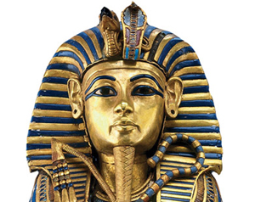

**Science**

This half term in Science our topic is Space. We will be finding out all about the planets in our solar system and the moon. We will carry out practical activities to find out about the movement of the Earth and how we get night and day.

**English**

We will be basing our English work around a picture book every half term and this term our book is ‘Farther’. Children will be given numerous writing opportunities, linked to themes in the book, that will cover a range of genres such as; information text, character description, letter and diary entry. Handwriting and SPaG sessions will be taught daily as well as comprehension and communication sessions that will give pupils the opportunity to develop their language skills.

Year 5: Autumn Term 1

PHARAOHS

**PE**

This half term are focus in PE is Invasion Games**.**

**PE sessions are Tuesdays and Fridays.**

**RE**

In RE we are focusing our work around the question ‘What are the Five Pillars of Islam?’. We will be exploring the concepts of duty, beliefs and values, comparing other faiths with our own.

**Mathematics**

**Place value – Numbers to 1000000**

Read and write numbers to 100000 and 1000000

Comparing numbers to 1000000

Identifying patterns in numbers

Number patterns – multiples of 10000 and 100000

Rounding numbers to the nearest 100, 1000, 10000 and 100000

**Addition and Subtraction**

Adding and subtracting numbers with 4 or more digits using formal written methods and adding and subtracting mentally with increasingly large numbers. Children will use rounding to check answers to calculations and determine, in the context of the problem, levels or accuracy. Children will be solving addition and subtraction multi-step problems in contexts, deciding which operations and methods to use and why.

**Creative Curriculum**

We are travelling back 5000 years to ancient Egypt, cruising along the Nile, entering a world of mysteries and curses, mummies and kings. During out topic we will be finding out about the fascinating culture of the Egyptians, unravelling the secrets of ancient tombs using historical sources. We will be researching the life of famous Pharaohs and what happened in the afterlife!