be

**English**

This half term we will be basing our English work around a book called ‘Pretty’. We will be writing lists, diary entries, recounts, character descriptions, reports and stories. We will also work on our spelling and grammar and will develop our comprehension skills using a range of different books and question types. This year we will be focusing a lot on handwriting, including writing neatly, forming our letters correctly and some of us will begin to join up.

**Mathematics**

In Maths we will continue to focus on our times tables and will be counting in 2s, 5s and 10s. We will recap our work on addition and subtraction through our 6 a day activities and throughout our maths lessons. The children will begin to learn about multiplication, focussing on multiplication as equal groups and progress onto solving word problems. We will also start to discover more about division, including grouping and sharing and will begin to answer word problems about this.

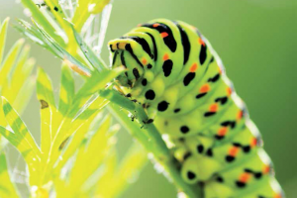

**Wriggle and Crawl – Autumn 2**

WOW – Animals takeover visitor

**Creative Curriculum**

Grab your coat – we’re going out and about on a minibeast hunt! We will hunt in bushes and trees to see who is home.

In creative curriculum this half term we will be finding out about different minibeasts. We will be classifying them based on their features and thinking about what they need to survive. We will also learn about habitats and microhabitats by exploring them and thinking about food chains. We will be writing some instructions about how to look after a range of minibeasts and will even be caring for our own class pet. The children will also be getting creative by creating and designing their own 3D minibeast model and composing music to represent the different minibeasts.

**PE**

We will be focussing on the fundamental movement skills such as throwing, catching, jumping, striking, running and agility. PE will be on Monday and Wednesday. Please ensure that your child’s PE kit is always in school on these days.

**Computing**

We will be learning about the internet, its uses and how it works. We will also be talking about e-safety and discussing how to stay safe on the internet.