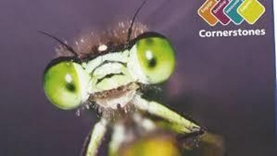

**English**

This half term are reading the narrative poem ‘The Highwayman’ by Alfred Noyes. We will be writing stories, diary entries and a balanced argument linked to the story. We will also be focusing on vocabulary from the poem and looking at using this in our own writing. Handwriting and SPaG sessions will be taught daily as well as comprehension and communication sessions that will give pupils the opportunity to develop their language skills. Our class novel is ‘The Explorer’ by Katherine Rundell.

Year 5: Spring Term 1

Beast Creator!

**Science**

In science our topic is ‘Living things and their habitats’. We will be finding out how plants and animals reproduce, the process of pollination and life cycles.

**Creative Curriculum**

A bug, a creepy-crawly, a beast! He’ll tickle your skin then go in for the sting!

This half term, our geography and art work will link to our topic on minibeasts. The children will be exploring minibeast from around the world, looking at where these countries are and what they are like. We will also be carrying out fieldwork in our local area – what minibeasts might live near us?

**PE**

Our PE lessons are on a Monday and Friday.

On Mondays our focus is athletics.

On Fridays our focus Zumba.

**Computing**

In computing we are creating our own computer game using the software scratch.

**Mathematics**

**Fractions**

To begin the topic, pupils divide whole numbers by whole numbers, giving rise to fractions. Pupils then show improper fractions and mixed numbers using pictures. As they progress, they find equivalent fractions, compare and order fractions and utilise the number bond strategy, known as number pairs, in their work with fractions. Next, pupils review adding fractions, with a focus on fractions with different denominators and fractions that create improper fractions and mixed numbers. Then they subtract fractions that are different, finding common denominators and subtracting mixed numbers and improper fractions. At the end of the topic, pupils begin to multiply fractions by whole numbers and multiply mixed numbers by whole numbers.