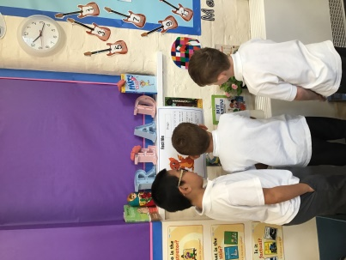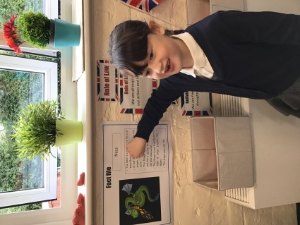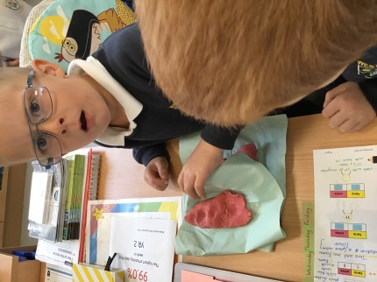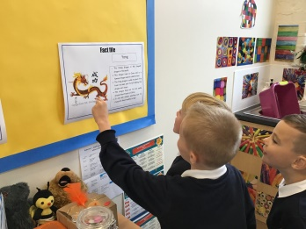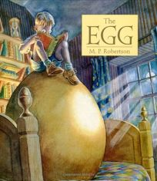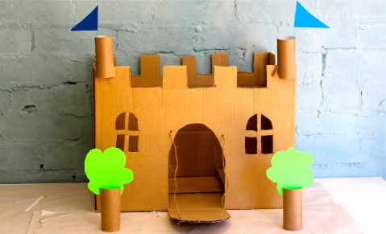

**“I wonder where the egg is?”**

**“I think it’s this one”**

**Investigating the Dragon that came to our class**

**Building castles and towers!**

**Book as a hook!**

This half term, Year 2 has been busy designing and building castles and discovering who once lived in them. Not only that! But we also found a Dragon egg in our class! We discovered it one morning when we went into our class to find that something had decided to mess our class room and leave lots of clues. Our job was to investigate what had happened and what Dragon had left all of the clues. At the moment we are keeping the egg warm and we are waiting for the egg to hatch to see what’s inside. What a busy half term!

