As Historians we will:
Learn about the changes in Britain from the Stone Age to the Iron Age.
Use a range of historical sources to find out more about the Stone Age.
Find out about life during the Bronze Age, researching clothing, homes, diet, farming, work and weather and discover how the rise of wealth and trade created tensions between settlements.
Use a range of sources to find out about the tribal life of Iron Age people, how they were led and ruled, where they built their homes and how they worked together to defend them.

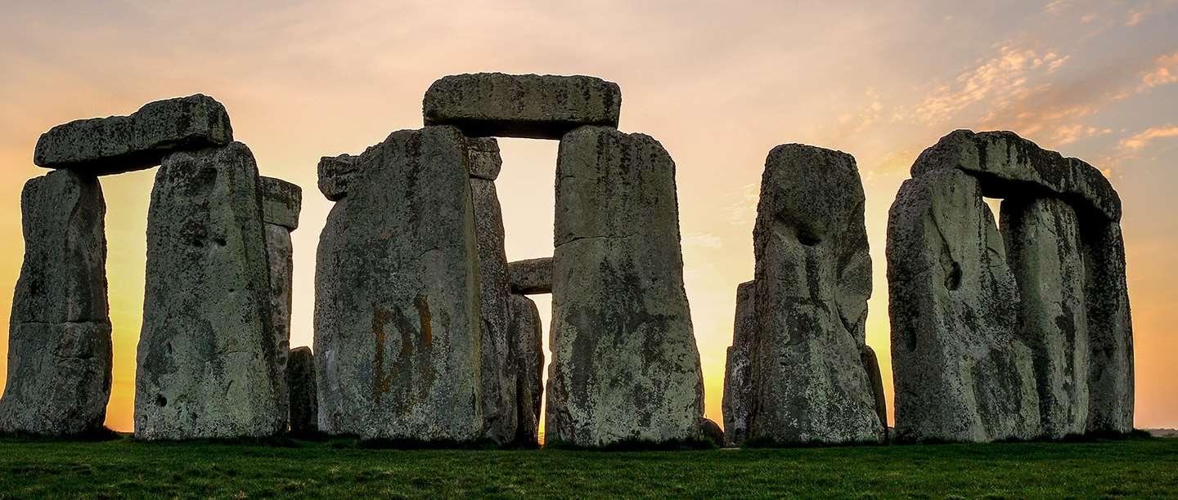
Tribal Tales
Year 3 – Spring Term
As Artists we will:
Look at examples of patterns and carvings by Neolithic people into rocks, boulders, panels and monuments describing how patterns are similar or different.
Use a variety of resources to investigate the designs of the Beaker folk, who were thought to have come to Britain from Europe during the Bronze Age.

As Designers we will:
Make woven baskets or fishing nets for hunting and gathering.
Construct shelters using found materials and add faux fur rugs and throws.

As Musicians we will:
Listen to and learn about the music of Bob Marley in particular the song 3 Little Birds.
We will learn what style of music Bob Marley wrote and performed and say what we like and dislike about it.
We will learn to sing the Song Three Little Birds and will use glockenspiels to add our own music.
In P.E we will:
Develop our skills in outdoor games.
Please ensure children have outdoor P.E Kit.
Swimming will start on Thursday 1st February.
Further information will be sent home nearer the time.
In PSHE we will:
Compare life in prehistoric times to our own lives today, considering what people living in those days may have worried about and compare these to modern day worries.

In Computing as Vloggers we will:
Put together a video blogg that teaches others about our theme Tribal Tales.

English
As Readers we will:
Consider why people need and use instructions.
Notice how instructions are organised to make them easy to follow.
Evaluate instructions against a set of criteria.

As Writers we will:
Write clear instructions about how to make a bottle band (musical instruments made out of bottles!)

As Mathematicians we will:
Learn a range of strategies to solve problems that involve multiplication and division.
We will explore efficient methods of working when solving problems in a range of contexts.

As Geographers we will:
Look at similarities and differences of landmarks in aerial photographs taken by archaeologists considering an excavation.
Discover how Stone Age farmers made use of the land, identifying how they improved or damaged it.
As Scientists we will:
Build small Bronze Age monuments and explore how shadows are created by them.
We will plant and grow grains and crops that Bronze Age farmers would have grown and learn about the life cycle of flowering plants.

Religious Education
We will ask: What do different people believe God is like?

As part of our Spiritual, Moral, Social and Cultural development we will: | To develop and further our understanding of Fundamental British Values we will:
Spiritual  - Explore chronology and our place in time and discover how past and present is interconnected  - Explore art in different environments  - Reflect on ways in which hunting nets improved the lives of people in the past  - Reflect upon the idea of God though art and music  Moral  - Explain why we think the choices made by others were right or wrong  - Explore sensitive issues linked with online safety  - Reflect on whether believing in God makes you a better person  Social  - Take an active part in historical visits and workshops  - Collaborate with others  - Understand how laws and rules have changed over time  - Listen and respond sensitively to other pupil’s ideas about God  - Explore maps to discover how people lived  Cultural  - Visit a museum and explore historical artefacts  - Explore art from a range of cultures  - Use technology to learn about the lives and beliefs of others.  - Recognise that culture and religion influence the diverse views and beliefs about God | Democracy  - Make decisions and come to a conclusions using historical evidence  - Work collaboratively on a task  - Take turns to share musical equipment  - Learn rules for different games and sports  Rule of Law  - Learn about rules and laws in the past  - Follow safety rules in science  - Use technology safely and responsibly  Individual Liberty  - Express an opinion about art in the past  - Select the tools and methods we feel are suitable and say why  - Use social vlogging to share views and opinions  - Express opinions about a song, piece of music or a performance  Tolerance and Respect  - Listen to and respect the views of others  - Learn about other cultures through traditional art  - Respect others views and opinions when creating digital content  - Respond to the music of Bob Marley, taking into account the impact of his words  - Explore the social, cultural and religious ideas that influenced the work of Bob Marley  - Play outdoor games co-operatively demonstrating respect
To develop our Online Safety knowledge we will:
- Use technology safely, respectfully and responsibly
- Recognise acceptable/unacceptable behaviour
- Identify a range of ways to report concerns about content and contact

