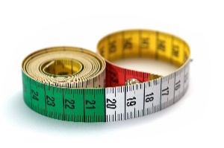  
  
  
  
  
  
  
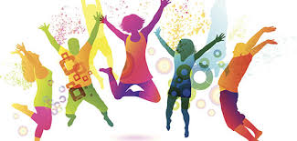!

Physical Education   
**Sports Count**

* This is a new initiative we are bringing to Year 2 this half term. Specific physical skills is still our focus, however there will be Mental Maths opportunities integrated within the lesson. The children will see Maths in a real life context as well as playing some very fun games.

Maths– No problem  
In this half term:   
  
Length

* Measuring in metres and centimetres
* Comparing lengths
* Solving word problems

Mass

* Measuring mass in kilograms and grams
* Comparing masses of different objects
* Solving worded problems associated with mass.

Religious Education   
In this half term: **Why does it matter to be part of a community? What can we learn about Christians and community life?**

We will be learning about the importance of community life and living well with other people for our well-being and happiness. Using examples from Methodist Christianity, we will explore belonging to a Church, a familing and the ‘whole wide world’. We will express our own sense of belonging and community life.

* We

**Year 2  
Spring 1  
Curriculum Map**

Creative Curriculum   
In this half term: **Land Ahoy!   
Why are pirates called pirates? … Because they arrrrggggg!**

* **As writers,** we are going to be putting our pirate hats on and pretending we are a deadly pirate from the past. Can we write a descriptive paragraph about our adventures at sea?
* **As historians,** we will be researching and finding new information about famous sea explorers. We will be plotting these on a pirate timeline.
* **As mathematicians** we are going to be investigating how much cargo we can carry back from our treasure hunt. We need to make sure the measurements are correct so it does not sink our toy ships.
* **As geographers** we are going to be exploring the globe to help Captain Cook plan his journey for treasure.
* **As scientists** we are going to be learning about how to keep healthy on a long journey out at sea. We will be learning about Charles Darwin’s sea journey to the Galapagos and about how babies of human and animals develop.

**Read, Write, Inc and Literacy**

* Continuing to improve our fluency of reading.
* Reading further exception words applicable to Year 2.
* Increasing knowledge of grammar terminology and being able to apply new skills.
* Developing our grammatical knowledge.