**As a writer we will be…**

* Learning to use grammar features in our writing, including prepositional phrases and subordinate conjunctions.

**As a reader we will be…**

* Learning different strategies to help us with our comprehension.
* Reading the texts Mr Majeika and The Worst Witch.

Year 3 Autumn Term

Tribal Tales

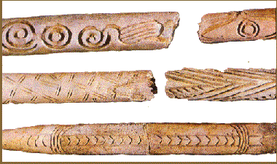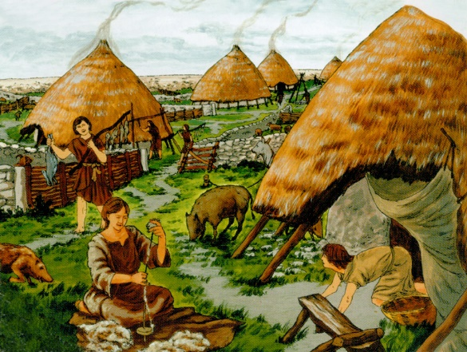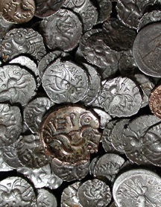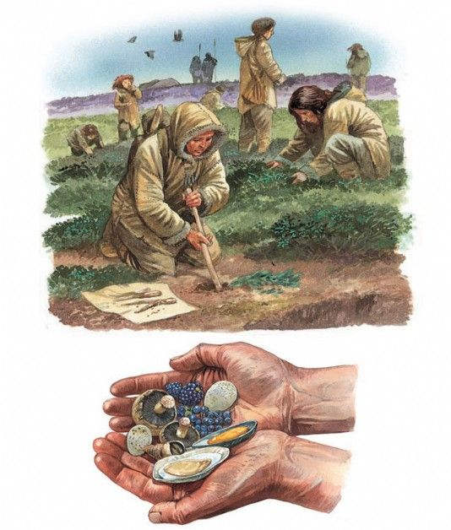

**In Religious Education, we will be…**

* Learning about different religious books and why they are important to individuals.

**As a historian we will…**

* Explore the differences between the Palaeolithic, Mesolithic, Neolithic, Bronze and Iron Ages.
* Find out about archaeologists and why they have an important role.

**As a geographer we will…**

* Use a range of different source materials, including the web, to find out how and why the Stone Age people evolved from hunter-gatherers to farmers.

**As a scientist we will be…**

* Learning how to classify different types of rocks.
* Investigating different types of soils.
* Exploring how fossils are formed and making our own fossils.

**As an artist we will be…**

* Looking at examples of patterns and symbols carved by Neolithic people into rocks, boulders, panels and monuments, describing how patterns are similar or different.

**As a mathematician we will be…**

* Multiplying by 3, 4 and 8.
* Solving word problems by dividing by 4 and 8.