Communication and language

I am learning to……

* Listen to stories and poems
* Be a good listener
* Talking with children about what they are doing and their achievements
* Follows an instruction and respond appropriately
* Lunch time manners
* Marvellous me Box

|  |
| --- |
|  |

Physical Development

I am Learning to…..

* Use the school toilets independently
* Wash hands properly
* Dress and undress for PE
* Look for own space in large groups
* Use and hold scissors / pencil correctly
* Fine motor and gross motor activities
* Understanding our bodies and how to keep them fit and healthy

|  |
| --- |
|  |

Personal, Social and Emotional Development

|  |
| --- |
| * Initiate conversations with adults * Initiate conversations with children * Speak with confidence in familiar group * Follow the class rules and routines * Remember the names of people in my class * Take turn in conversation * Take turns when playing games |

I am learning to …..

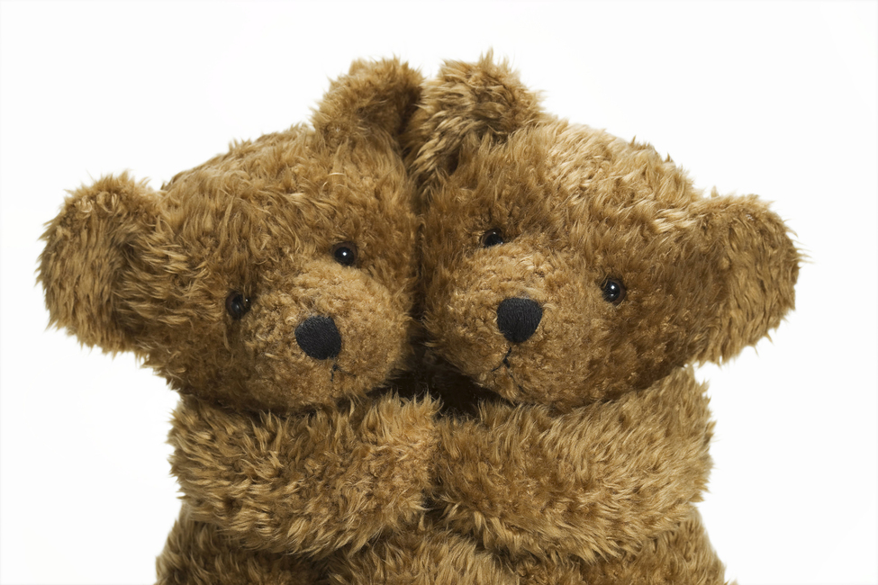

A warm welcome to our children and their parents and carers, particularly those who will be joining our school community for the very first time! This is the first newsletter of six which are sent each half term. Here, we provide information about what we plan to learn and discover during the coming weeks. This is alongside fostering the children's interests and desires. May we remind you that ALL children’s clothing should be clearly named! Snack money is £1.00 per week. If you have any questions or concerns please do not hesitate to ask. Thank you.

**The Reception Team Autumn 1 2018**

Literacy

I am learning to…..

|  |
| --- |
| * Read and write my own name * Hear rhyming words * Recognise words starting with the same letter. Snake, sun, star etc… * Recognise familiar sounds * Make marks and give meaning |

Understanding the World

I am learning to…..

* Talk about my holiday
* Compare similarities and differences
* Use simple programs on the computer
* Drag and drop using a mouse
* Celebrate Harvest Festival

|  |
| --- |
|  |

Expressive Arts and Design

I am learning to…..

* Sing songs from memory
* Mix colours making them lighter
* Role- play in home corner and supermarket
* Build models from different materials

|  |
| --- |
|  |

Mathematics

I am learning to….

|  |
| --- |
| * Recognise numbers 0-10 * Order numbers 0-10 * Count carefully 0-10 * Write numerals 0-10 * Sing number rhymes * Sort objects * Continue repeating patterns * Compare lengths and weight |