Communication and language

I am learning to……

* Listen to stories with interest
* Show and interest in playing with sounds, songs and rhymes
* Identify action words
* To use and understand the basic concepts of language big/little
* Uses language as a powerful way of widening and sharing feelings, experiences and thoughts

|  |
| --- |
|  |

Physical Development

I am Learning to…..

* To develop pencil control to mark make
* Show good control and co-ordination in large and small movements
* To climb confidently and be able to pull myself up using nursery climbing equipment
* Become more independent in my own self care

|  |  |
| --- | --- |
|  |  |

|  |
| --- |
|  |

Personal, Social and Emotional Development

|  |
| --- |
| * Try new activities with confidence and begin to understand that challenge helps us learn * To solve problems without aggression and continue to work as a team * Play cooperatively – Turn Taking and share ideas as well as listening to other ideas * Seek out others to share my experiences |

I am learning to …..

[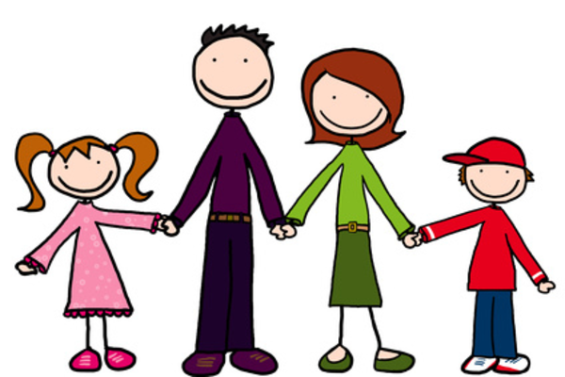](http://www.google.co.uk/url?sa=i&rct=j&q=&esrc=s&source=images&cd=&cad=rja&uact=8&ved=0ahUKEwip_c7Q-LvYAhWICsAKHbIFAgUQjRwIBw&url=http://www.sparklebox.co.uk/topic/world-around-us/society/people-who-help-us.html&psig=AOvVaw11cbm6t4Tdo17gM6Gl40ge&ust=1515073990596499)

**Autumn 1 is going to be a busy half term for Nursery as the children settle back into nursery and we welcome our new children. Our topic is Why do you love me so much. We will be finding out about our newly made friends in nursery and their families.**

**We would love to see learning at home and new experiences and this can be shared through Tapestry. Reminder: Snack Money £1 per week!**

**Thank you for your continued support.**

**The Nursery Team**

**Autumn 2 2017**

Expressive Arts and Design

I am learning to…..

* Join in singing favourite songs
* To explore with blocks of colour and marks
* To begin to make believe whilst playing
* To use movement to express feelings

|  |
| --- |
|  |

Understanding the World

I am learning to…..

* To have a sense of my own immediate family and relations
* To notice detailed features in my own environment
* Seek to acquire basic ICT skills like turning on simple equipment

|  |
| --- |
|  |

Mathematics

I am learning to….

|  |
| --- |
| * Selects a small number of objects from a larger group * Recite some number names in sequence * To understand some talk about the past and present experiences * To anticipate time-based events such as mealtime and home time |
|  |

Literacy

I am learning to…..

|  |
| --- |
| * Fill in the missing words from familiar stories, games and rhymes * Enjoy joining in rhyme and rhythmic activities * Start beginning to recognise rhyme and alliteration * To distinguish between the different marks that I make |