[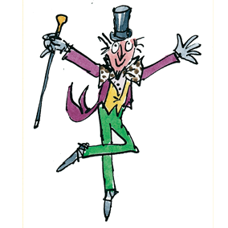](https://www.google.co.uk/url?sa=i&rct=j&q=&esrc=s&source=images&cd=&cad=rja&uact=8&ved=2ahUKEwinoeymt6TdAhXrzIUKHYWaCSEQjRx6BAgBEAU&url=https://twitter.com/stmarysenglish/status/850262601938247684&psig=AOvVaw032LNq-W3HH910UgtekCVc&ust=1536256424475439)

Year 3 Autumn Term

**As a reader we will be…**

* Listening to a range of stories by the famous author Roald Dahl and exploring his use of descriptive language.

**As a writer we will be…**

* Writing a new description filled chapter to Roald Dahl’s story ‘Charlie and the Great Glass Elevator’.

[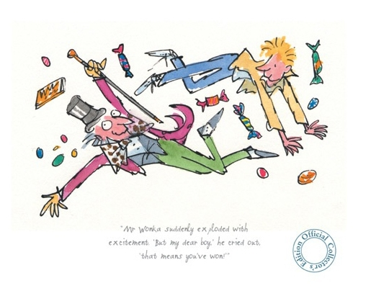](http://www.google.co.uk/url?sa=i&rct=j&q=&esrc=s&source=images&cd=&cad=rja&uact=8&ved=2ahUKEwj7zsC9t6TdAhVqxoUKHYgSDLkQjRx6BAgBEAU&url=http%3A%2F%2Fptod.pichkarno.co%2Fwriter-of-charlie-and-the-chocolate-factory.html&psig=AOvVaw16kFTlzZO1ELxktv713YLM&ust=1536256464068020)[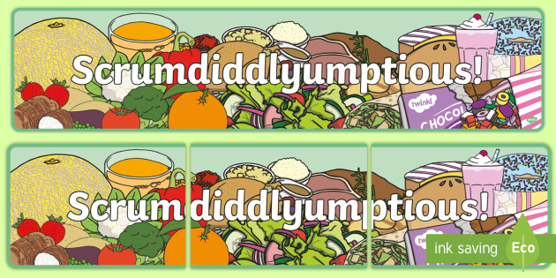](https://www.google.co.uk/url?sa=i&rct=j&q=&esrc=s&source=images&cd=&cad=rja&uact=8&ved=2ahUKEwi3lZ_ds6TdAhUpxoUKHQN-A_8QjRx6BAgBEAU&url=https%3A%2F%2Fwww.twinkl.co.uk%2Fresource%2Ft-t-2548125-scrumdiddlyumptious-display-banner&psig=AOvVaw3t59QbIfBtgn37TV-NqArw&ust=1536255465844081)

**As a scientist we will be…**

* Learning how to classify different types of food using scientific language to describe the food types.
* Design a healthy, balanced meal.
* Investigate how different foods can be changed. We will observe and record our findings.

**As a mathematician we will be…**

* Learning about the place value of numbers up to 1000.
* Learning our 4 and 8 times table.

**As an artist we will be…**

* Exploring the artwork of Pablo Picasso.
* Observing and drawing different fruits and vegetables.
* Using artistic skills, such as colour, pattern and form.

**In Religious Education, we will be…**

Learning about different religious books and why they are important to individuals.

**As a musician we will be…**

Let Your Spirit Fly. The material presents an integrated approach to music where games, the dimensions of music (pulse, rhythm, pitch etc), singing and playing instruments are all linked.Listening to the song ‘Let it fly’ and will learn about pulse, rhythm and pitch through playing games and playing musical instruments.

**As a geographer we will…**

Be exploring the meaning of the words ‘Fair Trade’ we will discover where our food comes from. We will use maps and atlases to plot the journey of the fruit that we eat from farm to fruit basket.