Computing

The children will be Game Developers, planning their own computer games and designing their own characters.

RE

In RE this term the children are going to explore the five pillars of Islam

Homework

Children should try to read 3 times a week and have an adult sign their planner. They should practise timetables so that they know all of them fluently,

Science

Science this half term will focus on Space; exploring the planets, the way they move and about the galaxy.

PE

The children will participate in two PE lessons a week with myself and Elite coaches.

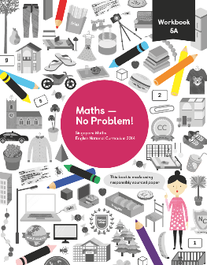

Year 5

Autumn 1

Maths

To begin our year, we will focus on place value looking at reading, writing and comparing numbers to 1 000 000. We will explore number patterns and rounding before moving to addition and subtraction.

English

Wolves in the Wall

By Neil Gaiman

[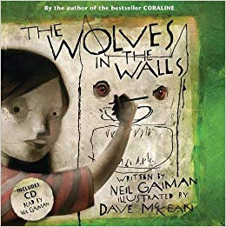](https://www.google.co.uk/url?sa=i&rct=j&q=&esrc=s&source=images&cd=&cad=rja&uact=8&ved=2ahUKEwiG3sCu86PdAhUsL8AKHXrrDgcQjRx6BAgBEAU&url=https%3A%2F%2Fwww.amazon.co.uk%2FWolves-Walls-Book-CD%2Fdp%2F0747591628&psig=AOvVaw0_vMnKhJxVujdp8lUa2YIM&ust=1536238188906280)

We will be developing our new English curriculum; using a book to hook the children into writing. Alongside this we will we will focus separately on comprehension skills, spelling and the grammar for Year 5 and 6 within separate SPaG lessons,

Creative Curriculum

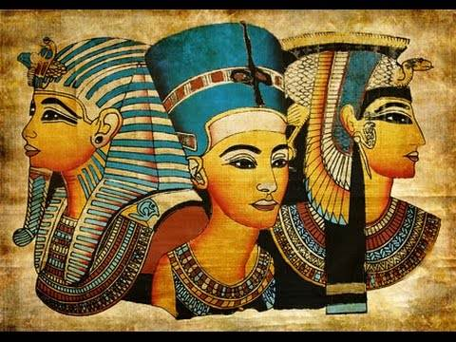

This half term we will be looking at the topic ‘Pharaohs. This travels back 5000 years to the dusty realms of Egypt entering a world of mysteries and curses, mummies and kings.