Communication and language

I am learning to……

* Listen to stories and poems without pictures or prompts
* Listen with great attention to others
* Contribute purposefully in discussion
* Begin to use language that suggests story imitation
* Introduces a storyline to play

|  |
| --- |
|  |

Physical Development

I am Learning to…..

* Travel with confidence and finding new ways to travel
* Gain speed when dressing and undressing for PE
* Use simple tools to effect change to materials
* Begin to show understanding of exercise and eating healthily
* Shows understanding of safety

|  |
| --- |
|  |

Personal, Social and Emotional Development

|  |
| --- |
| * Talk about myself and my abilities * Continue to follow the class rules and routines * Share interests with peers and build on experiences * Explain understanding and ask appropriate questions * Take steps to revolve conflict |

I am learning to …..

**Hibernation**

**Autumn 2 is going to be another busy half term for Reception as we learn all about hibernation and the different seasons. Please continue to support your children with their homework and daily phonics sounds. We would love to see learning at home and new experiences and this can be shared through Tapestry.**

**Reminder: Snack Money £1 per week**

**Thank you for your continued support.**

**The Reception Team**

**Autumn 2 2017**

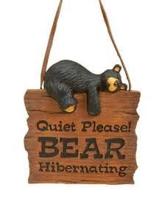

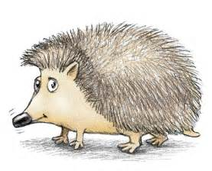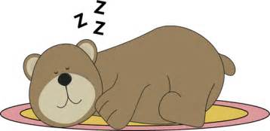

Literacy

I am learning to…..

|  |
| --- |
| * Hear and say initial sounds in words * Can segment sounds in simple words and blend them together * Enjoy an increasing range of books * Explore new stories and use within my mark making |

Expressive Arts and Design

I am learning to…..

* To build a repertoire of songs and dances
* Explore sounds of instruments
* Constructs with purpose with a planned outcome
* Explore different materials and colours
* Explore autumnal setting and use within play

|  |
| --- |
|  |

Understanding the World

I am learning to…..

* Explore bonfire night
* Explore seasons and differences within environment
* Hibernation
* Light and dark
* Christmas

|  |
| --- |
|  |

Mathematics

I am learning to….

|  |
| --- |
| * Order numbers 0-10 * Count carefully 0-10 * Write numerals 0-10 * Continue repeating patterns * Compare lengths and weight * Use mathematical language for 2D and 3D shapes |
|  |