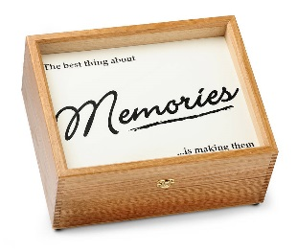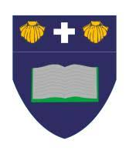

**Creative Curriculum**

This half term our Creative Curriculum topic is Memory Box!

As Artists, we will be using a range of craft materials and paint to make our very own memory boxes! We will bring them home to keep our treasures safe!

As Historians, we will be finding out about the past after our discovery of a time capsule! We will be asking questions about how our local area has changed since the 1900s, how toys have changed and how our school has changed. We will be using a range of sources such as pictures, real artefacts and first-hand experiences from older adults.

As Geographers, we will be finding out about our local town, Leigh. We will be exploring the human and physical features within our school and the local area. We will also be looking at old pictures of Leigh to see how it has changed over the years.

As Designers, we will be designing, making and evaluating our very own Christmas toy!

Year 1

Curriculum Map Autumn Term 2

English

As readers, we continue to use Read Write Inc to teach phonics. Your child will be learning all the phonemes and graphemes, through a differentiated approach. This will ensure that they are confident to segment and blend the learned sounds when reading real and alien words. Also, your child will engage in daily reading through the scheme. They will read a text that is closely suited to their current phonetic knowledge. It will encourage them to segment and blend sounds they are familiar with, as well as ‘tricky’ words.

Your child will be sent home a Book Bag Book, which has been selected to reinforce their phonetical knowledge and reading skills outside of school. As a school, we recognise that importance of reading and suggest that 5 minutes is spent every night to enjoy reading together. We have a reading reward scheme in class, where the children receive a stamp for reading at least 3 times a week. If they get 4 stamps over the half term, they can join in with the reading reward. This half term we will be enjoying a Christmas film with popcorn and hot choclate!

As writers, we will be using a picture book as a stimulus for our writing, through a Book as a Hook curriculum. This half term our book is ‘The Polar Express’. We will be practising our sentences out loud before we write them down. We will also be using a sound mat to ensure that we are trying our best to spell words accurately.

In PE, we will be working with Elite Sport on a Monday morning and Tuesday afternoon. We will be learning to be good sports leaders this half term.. Please ensure your child has kit every Monday and Thursday.

As Musicians, we will be learning all the songs and dance moves for our Christmas play! We can’t wait to perform for you!

In Computing, we will be becoming TV chefs! We will learn to follow a set of instructions to make healthy snacks. We will be filming each other to create a TV cooking show!

As Scientists, we will be exploring the question ‘Who Am I?’. We will be learning about the different parts of the human body, our organs and our senses. We will be labelling our own human body. We will be putting our senses to the test in a range of scientific investigations to explore how they really work.

Religious Education

Our RE focus question is ‘Why do Christians celebrate Christmas?’

Spiritual: Explore the idea of giving and receiving gifts. Pupils reflect on their own experience of gifts and gift giving. Is it better to give or receive a gift?

Moral: Explore with pupils which gifts are the most valuable and why.

Social: Explore how Christmas is celebrated by Christians in the church.

Cultural: Explore how Christmas is celebrated in the UK.

**Maths No Problem**

As mathematicians, we will be learning about the place value of numbers to 10. We will also be discovering different strategies that will help us to confidently add and subtract numbers up to 10. We will also be thinking about positions and directions and using these to program Beebots.

We will be learning through Maths No Problem, which encourages all learners to become actively engaged in their learning, efficient problem solvers and cooperative, resilient learners.