**As a writer we will be…**

* Learning to write persuasively.
* Using the book Billionaire Boy written by David Walliams as inspiration for our writing.

**As a reader we will be…**

Learning how to use inference skills when reading a text.

Year 3 Spring Term

Gods and mortals

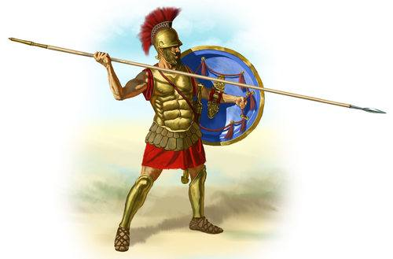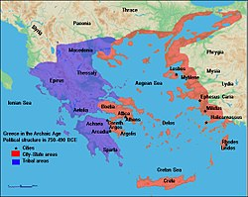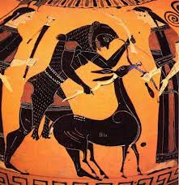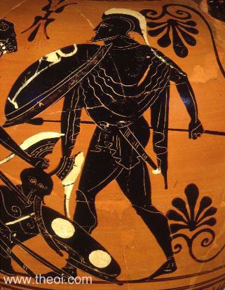

**As a scientist we will be…**

* Learning about how we see objects.
* Finding out how light can be effected by objects that are transparent, translucent and opaque.
* Discovering how and why we should protect our eyes.

**As a geographer we will…**

* Use different types of maps to locate the physical features in Greece, like the mountains and volcanoes.

**As an artist we will be…**

Using chalk and oil pastels to create artwork found on Ancient Greek plates.

**As a historian we will…**

* Exploring the different Ancient Greek Gods and why they were so powerful.
* Find out about the legacy that the Ancient Greeks have left behind.
* Putting dates chronologically on a timeline.

**As a mathematician we will be…**

* Multiplying by multiples of 10.
* Dividing with regrouping.