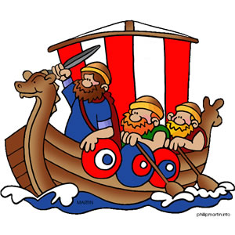

Maths:

We will be focussing on place value in numbers up to 10,000. We will compare and order 4-digit numbers. We will also be looking at addition and subtraction, improving our mental strategies and working with remainders.

As Artists and Designers we will:

Study Anglo-Saxon pattern work and create our own printed patterns. Sketch images of Viking gods, developing our sketching techniques. Create models of Anglo-Saxons homes using recycled materials.

Year 4 – Autumn 1

Traders and Raiders

As Historians we will:

Study the Anglo=Saxon and Viking period. We will learning about the key events between 410AD and 1066 and look at famous historical characters from this era. We will learn about Viking gods and Alfred the Great. We will also explore myths and legends from this era such as Beowulf and King Arthur.

R.E.:

We will be investigating the question ‘Can religious teachings help us decide the best way to live?’ enquiring into why rules are important and what we can learn from moral stories.

English:

We will be looking at the book ‘I want my hat back’. Pupils will develop their writing skills. They will create a number of pieces based around a variety of genres.

As Scientists we will:

Learning about our amazing digestive system and how it works! Learning about our different types of teeth and why it is important to keep them healthy!

As Geographers we will:

Identify Anglo-Saxon kingdoms on a map and trace the journey the Angles, Jutes and Saxons took to invade Britain.