Year 3

Summer term

**As a writer we will be…**

* Learning to write mystery and adventure stories.
* Describing mythical characters and story settings.
* Getting inspiration from C.S. Lewis’ the Lion, Witch and the Wardrobe.

**As a geographer we will…**

* Be using ordinance survey maps to locate different rivers.
* Be labelling different parts of a river.
* Be learning about the water cycle.
* Finding out about Hydro-power.

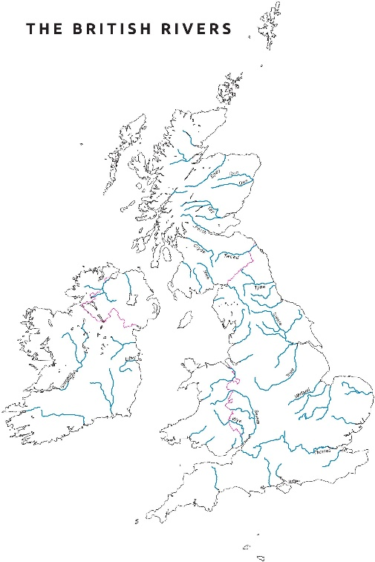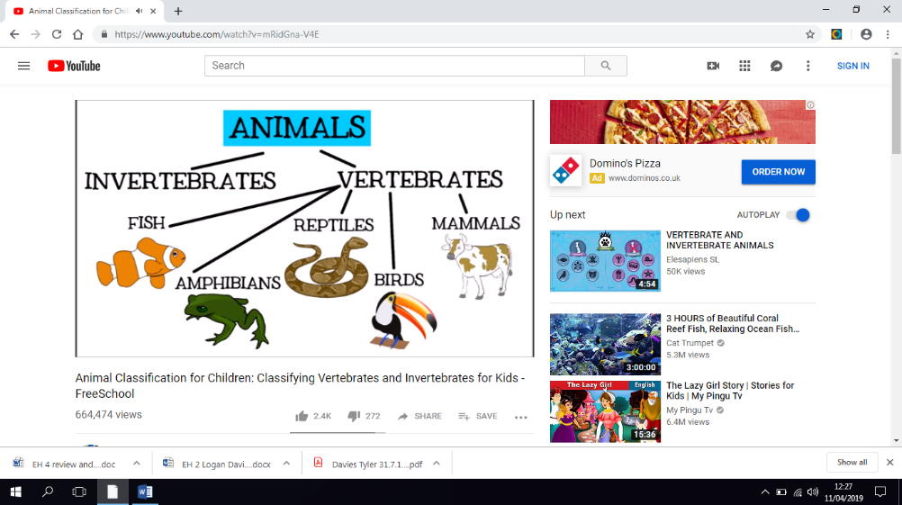

**As a mathematician we will be…**

* Learning to read the time.
* Converting analogue time to digital time.

**As a reader we will be…**

Learning how to use inference skills when reading a text.

**As a scientist we will be…**

* Naming and grouping animals including: reptiles, amphibians, mammals and more.
* Grouping animals according to whether they are vertebrates or invertebrates.
* Exploring the food chains of different animal groups.

**As an artist we will…**

* Be creating ephemeral art work using natural materials that we find in the environment.
* Be exploring different land artists like Andy Goldsworthy and Peter Randall-Page.

Flow