**As a mathematician we will be…**

* Finding the volume of different liquids.
* Adding and subtracting amounts of money.

**As a writer we will be…**

* Learning to write an information text about the Blitz.
* Reading the story ‘Time Train to the Blitz’ written by Sophie McKenzie as inspiration for our writing.

Year 3 Spring Term 2

Gods and mortals

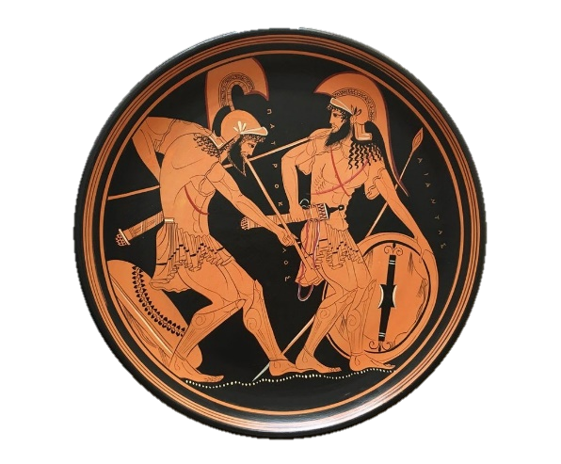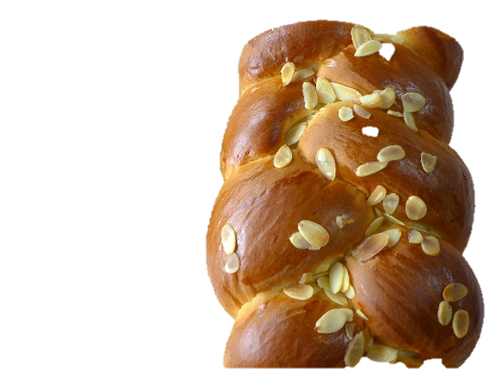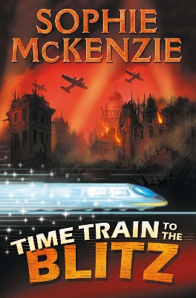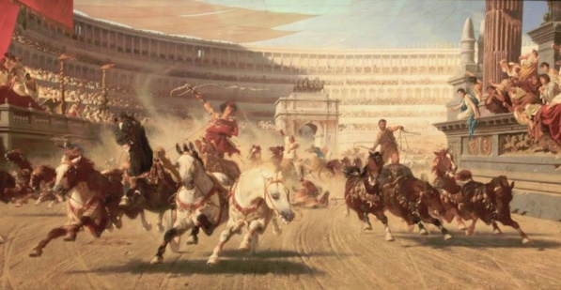

**As a scientist we will be…**

* **Comparing how things move on different surfaces.**
* **Observing how magnets can attract or repel each other.**
* **Identifying which materials have magnetic properties.**
* **Describing how magnets can have two poles.**

**As an artist we will be…**

* Creating our own stamps and printing our designs to create a Greek style plate.

**As designers we will be…**

* Evaluating existing products.
* Developing our own design criteria.
* Making our own Greek style breads and evaluating our products.

**As a historian we will…**

* Find out about the legacy that the Ancient Greeks have left behind.
* Posing our own enquiry questions about the Ancient Olympic Games.
* Considering the similarities and differences between the modern and Ancient Games.

**As a reader we will be…**

* Identifying the meaning of words within a text.