Computing

‘We are Web Developers’

The children will be learning how to create their own website around online safety.

Science Science this half term will focus on ‘Properties and changes of materials’: exploring different states, properties of material and the changes that can take place.

RE

In RE this term, we will be asking the question: ‘Why is Easter so important to Christians?’ We will discuss the Easter story and learn about resurrection, sacrifice and forgiveness.

PE

The children will participate in two PE lessons a week with myself and Elite coaches.

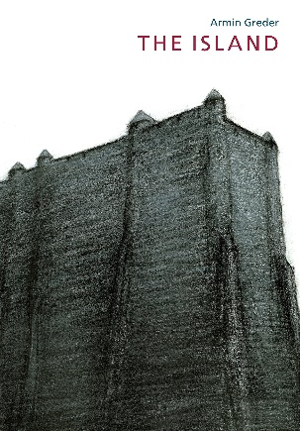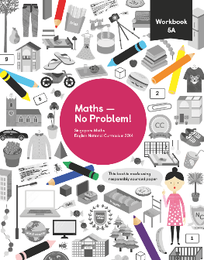

English The Island Armin Greder

Year 5 are going to explore the topic of refugees and their treatment through the story ‘The Island’. During this, we will write letters, monologues, newspaper reports, narratives and arguments and continue to work on SPaG separately.

Maths

This half term sees Year 5 completing our work on fractions before moving onto decimals and percentages. We will finish with Geometry where we will explore properties of shape.

Creative Curriculum

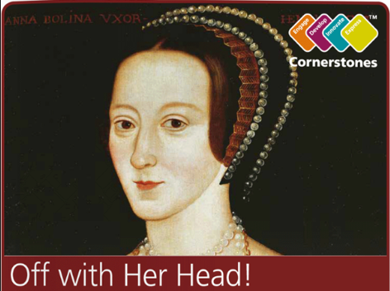

The next 2 half terms we will be looking at the topic ‘Off with Her Head’. ‘What sort of man would order the beheading of his wife? Was she really that bad? Travel back in time to the 1500s and meet the terrifying Tudors, a domineering dynasty that changed our history.’

Year 5

Spring 2