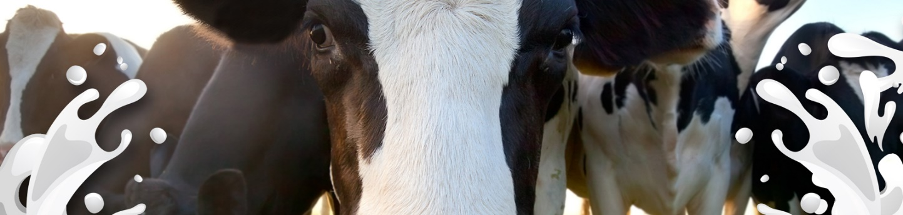

Literacy

I am learning to…..

|  |
| --- |
| * Talk about the stories I have read with others * Uses phonic knowledge to decode regular words and reads them aloud * Continue with Read Write Inc * Write simple sentences which can be read by myself and others |

Mathematics

I am learning to….

|  |
| --- |
| * Use everyday language to talk about size, weight, capacity, position, distance, time and money to compare quantities and objects and to solve problems * Counts reliably with numbers from 1 to 20, places them in order and says which number is one more or one less than a given |
|  |

Physical Development

I am Learning to…..

* To develop correct pencil grip to support letter formation
* Show good control and co-ordination in large and small movements
* To continue with balance, rolling, performance, routines within gymnastics
* Make healthy choices

|  |  |
| --- | --- |
|  |  |

|  |
| --- |
|  |

Expressive Arts and Design

I am learning to…..

* Safely use and explore a variety of materials, tools and techniques, experimenting with colour, design, texture, form and function
* Represents own ideas, thoughts and feelings through design and technology, art, music, dance, role-play and stories

Old Macdonald had a farm, e-i-e-i-o! Do cows drink milk? What are baby pigs called? It’s time to find out more about life on the farm and the animals that live there. Spring 2 is going to be another busy half term, with chick hatching and a farm visit. Please continue to support your children with their homework and Read Write Inc. We would love to see learning at home and new experiences can be shared through Tapestry or filling out a ‘WOW’ moment.  **Reminder: Snack Money £1 per week!**

**Thank you for your continued support.**

**The Reception Team**

**Autumn 2 2017**

Understanding the World

I am learning to…

* Make observations of animals and plants through the chick hatching and farm visit
* Look at similarities and differences between myself and others, and among families, communities and traditions.
* Look at similarities and differences in relation to places, objects, materials and living things.
* Select and use technology for a particular purposes

|  |  |
| --- | --- |
|  |  |

|  |
| --- |
|  |

Communication and language

I am learning to……

* Gives his/her attention to what others say and responds appropriately
* Uses past, present and future forms accurately when talking about events that have happened or are to happen in the future
* To answer ‘how and ‘why questions

|  |
| --- |
|  |

Personal, Social and Emotional Development

I am learning to…

* To confidently try new activities and say why he/she likes some activities more than others
* Share feelings, talk about differences and accept other people opinions
* Show sensitivity to others and continue to build positive relationships

|  |
| --- |
|  |