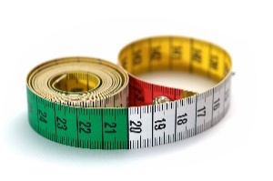  
  
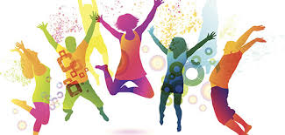!

Physical Education   
**Sports Count**

* We will be continuing with combing physical skills and maths opportunities this half term. The children will use their knowledge of maths facts to play games work together,

Maths– No problem  
In this half term we will lear about:   
  
Money

* Counting money.
* Showing equal amounts of money.
* Calculating change

Fractions

* Showing halves, quarters and thirds
* Comparing and ordering
* Counting in halves, quarters and thirds

Religious Education   
In this half term: **Christianity: the church**

We will:

• investigate the church as a building and what happens there;

• become familiar with the names of parts of a church;

• develop our ability to apply what we learn about one church to a place of worship from another religion

others.

* We

**Year 2  
Spring 2  
Curriculum Map**

Creative Curriculum   
In this half term: **Wriggle and Crawl**

* **As geographers** we will investigate our school surroundings to decide where best to search for minibeasts.
* **As artists** we will investigate how symmetry is seen in the natural world and learn about line and pencil techniques for drawing insects as used by Natalie Mcintyre.
* **As designers** we will study camouflage and use our knowledge to design minibeast models which blend in to the school environment.
* **As scientists** we will continue to learn and investigate about the needs of humans and other animals, especially insects, and how they keep healthy and well.
* **As historians** we will learn about Florence Nightingale and Mary Seacole who contributed to the health and wellbeing of people in the past and compare hospitals now and then.

**Read, Write, Inc and Literacy**

* Continuing to improve our fluency of reading.
* Reading further exception words applicable to Year 2.
* Increasing knowledge of grammar terminology and being able to apply new skills.
* Developing our grammatical knowledge.