  
  
  
  
  
  
  
  
  
  
  
  
  
  
  
  
  
  
  
  
  
  
  
  
  
  
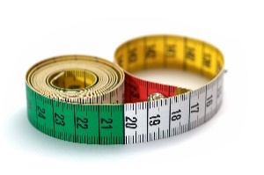  
  
!

Physical Education   
**Games**

* We will be We will be developing our team working and collaborative skills by applying the techniques we have developed so far in the year towards a variety or summer games in preparation for sports day.

Maths– No problem  
In this half term we will be consolidating and revising our learning for this year to prepare us for Ks2. We will be revisiting the four operations with an emphasis on problem solving, and will be applying our knowledge of measures including money and time more broadly.

Religious Education   
In this half term: **Islam**

We will be enquiring into key questions arising from the study of religion and belief, to promote their personal and spiritual development. We will be asking why god is important to Muslims to find out what Muslims believe about God, humanity and the natural

world and how this compares to the beliefs of children in class and our school.

others.

* We

**Year 2  
Summer 2  
Curriculum Map**

Creative Curriculum   
Continuing with last terms topic we will be…. **Beach Combers**

* **As geographers** we will be investigating the terminology and characteristics of different locations including beaches.
* **As artists** we will be developing our understanding of tone and shadow to sketch shells and fossils and we will be creating natural sculpture in the style of Andy Goldsworthy.
* **As designers** we will create kites suitable for different locations and evaluate their effectiveness.
* **As historians** we will learn about how holidays have changed in living memory.
* **As scientists** we will learn about how marine animals have adapted differently to their habitats. We will learn about what we mean by living things and about how ecosystems work, particularly about food chains.

**Read, Write, Inc and English**

* We will be drawing on our reading to write more independently, using our drafting and editing skils we have been developing all year.
* We will continue to increase our knowledge of grammar terminology and apply these skills to our writing.