Science Science this half term will focus on ‘Animals including Humans.’ We will describe the changes as humans develop to old age.

RE

‘Why do believers see life as a journey?’

In RE we will continue to explore the journeys people take from different religions. Looking at different passages in life, such as marriage.

Computing

‘We are Architects’

This half term the children will be creating their own virtual gallery and displaying their artwork within.

PE

The children will participate in two PE lessons a week with myself and Elite coaches.

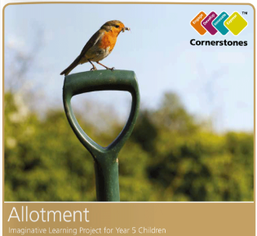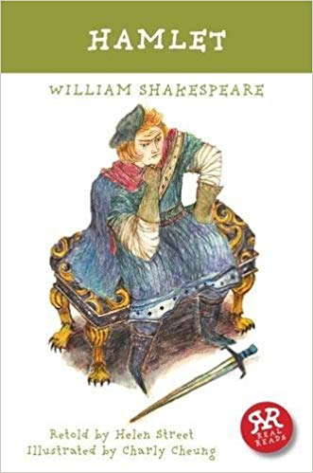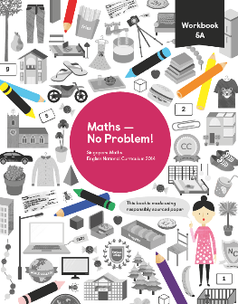

English

Hamlet

William Shakespeare

This half term we are continuing to study the play ‘Hamlet’ by William Shakespeare, a Tudor playwright.

We will write diary entries, play scripts and stories using the play as inspiration. This will continue alongside our separate Grammar lessons.

Creative Curriculum

This half term we will be starting a new topic called ‘Allotment.’

‘Let’s grow a crispy carrot, a luscious lettuce or a tasty tomato. Dig deep and put your back into it, making your own tubs and planters and nurturing your greens.’

Maths

This half term we will be looking at position and movement of shapes within a graph, measurement, area and perimeter before completing our Math’s curriculum with volume.

Year 5

Summer 2