  
  
  
  
  
  
  
  
  
  
  
  
  
  
  
  
  
  
  
  
  
  
  
  
  
  
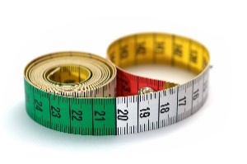  
  
!

Physical Education   
**Games**

* We will be We will be developing our team working and collaborative skills by applying the techniques we have developed so far in the year towards a variety or summer games.

Maths– No problem  
In this half term we will be consolidating and revising our learning for this year to prepare us for our tests. We will also be learning about the properties of shapes and tackling more complicated word problems, applying our knowledge of the four operations.

Religious Education   
In this half term: **Islam**

We will be enquiring into key questions arising from the study of religion and belief, to promote their personal and spiritual development. We will be asking why god is important to Muslims to find out what Muslims believe about God, humanity and the natural

world and how this compares to the beliefs of children in class and our school.

others.

* We

**Year 2  
Summer 1  
Curriculum Map**

Creative Curriculum   
In this half term and next half term: **Beach Combers**

* **As geographers** we will be investigating the terminology and characteristics of different locations including beaches.
* **As artists** we will be developing our understanding of tone and shadow to sketch shells and fossils and we will be creating natural sculpture in the style of Andy Goldsworthy.
* **As designers** we will create kites suitable for different locations and evaluate their effectiveness.
* **As historians** we will learn about how holidays have changed in living memory.
* **As scientists** we will learn about how marine animals have adapted differently to their habitats. We will learn about what we mean by living things and about how ecosystems work, particularly about food chains.

**Read, Write, Inc and English**

* Most of the children will now be moving away from the phonics program to access the wider English curriculum in more depth and continue to develop their vocabulary and comprehension.
* We will continue to increase our knowledge of grammar terminology and apply these skills to our writing.