RE

‘Why do believers see life as a journey?’

In RE we will explore the different rites of passage people go through during life and reflect on our own journeys.

Computing

‘We are Bloggers’

This half term the children will be looking at blogging – what it consists of, how it is possible and how to create their own.

Science Science this half term will continue to focus on ‘Properties and changes of materials’: exploring different states, properties of material and the changes that can take place.

PE

The children will participate in two PE lessons a week with myself and Elite coaches.

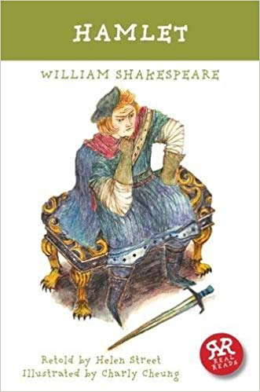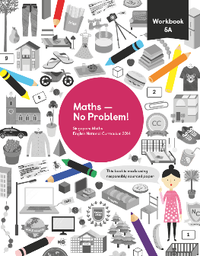

Creative Curriculum

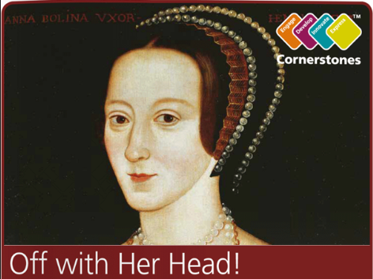

This half term we will continue our topic ‘Off with Her Head’.

‘What sort of man would order the beheading of his wife? Was she really that bad? Travel back in time to the 1500s and meet the terrifying Tudors, a domineering dynasty that changed our history.’

English

Hamlet

William Shakespeare

This half term we are going to study the play ‘Hamlet’ by William Shakespeare, a Tudor playwright.

We will debate, write arguments and write our own play in a Shakespeare style. This will continue alongside our separate Grammar lessons.

Maths

This half term we will measure, investigate and draw angles within Geometry. We will also look at position and movement of shapes within a graph before finishing with measurement.

Year 5

Summer 1