Communication and language

* Focusing on answering questions in response to play based activities
* Discussing familiar stories on known theme: Why does …? What if …? Why did you say…?
* Understanding prepositions through playing games and completing obstacle courses.
* Understanding the importance of following instructions by planting seeds.

Physical Development

* Construct art forms and mazes from large and small resources
* ‘Doodlesticks’ for fine motor skills
* Move like mini beasts
* Play traditional games
* Increasing speed and confidence when taking our coats on and off.
* Look at natural foods and what foods are good for us and which are not
* Make our top 5 healthy tips
* Make a class book ‘Be Healthy and Safe’

Personal, Social and Emotional Development

* Exploring feelings through picture stimulus.
* Discuss: The Bad Tempered Ladybird, Titch, Jack and the Beanstalk, Shrinking Sam
* Discussing ourselves, families and communities and understanding that these can be different and are all special and unique.
* Continue to encourage children to help one another and support each other in their learning-stopping continuous provision to discuss good examples as they happen.

Plants, growth and mini beasts

Nursery Summer 1 2019

Snack money is £1.00 per week which should be placed in a named, sealed envelope. Please remember you are encouraged to send details of your child’s learning outside school via Tapestry or by completing a WOW moments sheet. Please ensure that all your children’s clothing is fully labelled. Thank you.

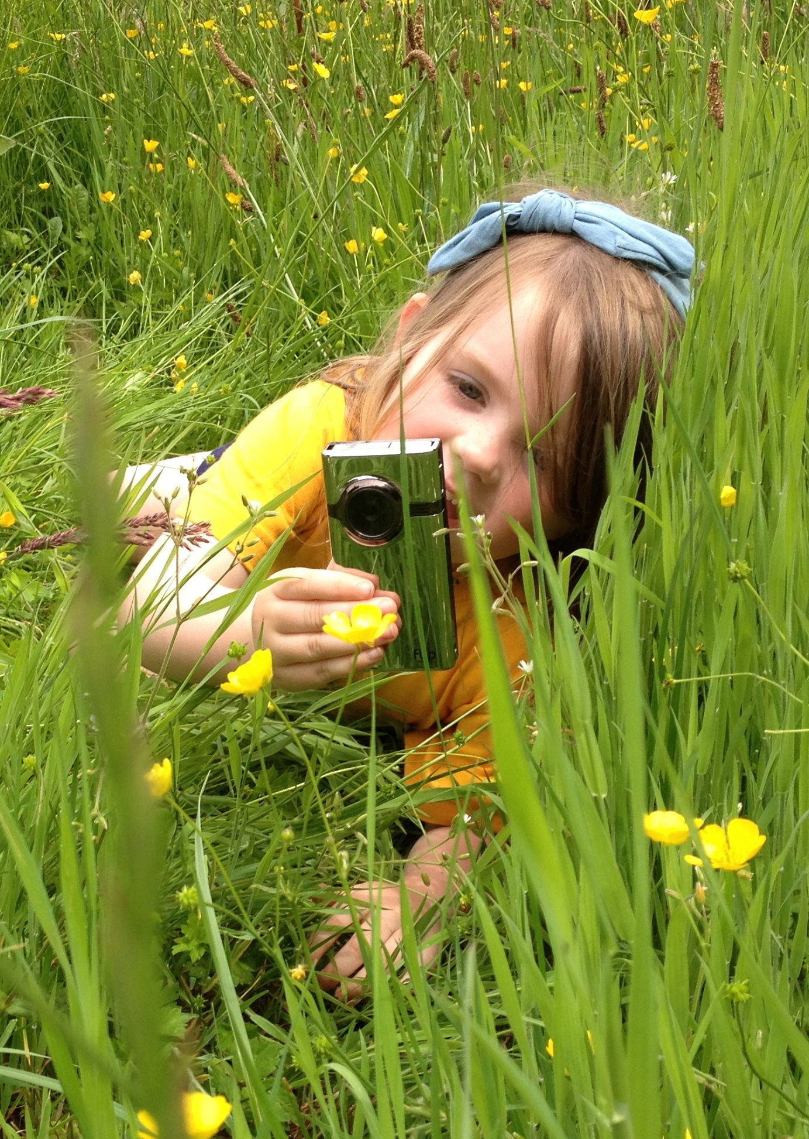

Expressive Arts and Design

* Make music to match the world around us
* Create mini beast dances and masks
* Work in clay and then in paint to make mini beasts
* Sketching real life
* Making tall sunflowers and beanstalks (adapting work to support more height)

Mathematics

* Daily counting on and back from a given number
* More/less bingo & mini beast/ fruit and veg. addition and subtraction- model counting on and back
* Problem solving within cooking
* Dragonfly patterns
* Measuring distance in the ant maze
* Measuring the height of growing plants and record

Literacy

* Read and write instructions caring for plants, recipes
* Sort themed books - explain your reasoning
* Make mini books on popular stories
* Note down findings from Study Centre
* Add sentences to given pictures of unusual plants

Understanding the World

* Investigate what plants need to live & grow
* Discussing how humans grow and change and their differences
* Using technology to answer questions and record information
* Sorting and categorising mini beasts

Expressive Arts and Design

* Make music to match the world around us
* Create mini beast dances and role play masks
* Work in clay and then paint to create life like mini beasts/sketch real life
* Making tall sunflowers and beanstalks (adapting work to support more height )

Mathematics

* Recognition of the same quantities
* Developing mathematical language in everyday contexts
* Problem solving through planting including positional language
* Patterns and shapes in nature and the environment
* Reciting numbers in order and developing accuracy by counting apples on the tree.

Mathematics

* Daily counting on and back from a given number
* More/less bingo & mini beast/ fruit and veg. addition and subtraction- model counting on and back
* Problem solving within cooking
* Dragonfly patterns
* Measuring distance in the ant maze
* Measuring the height of growing plants and record

Mathematics

* Daily counting on and back from a given number
* More/less bingo & mini beast/ fruit and veg. addition and subtraction- model counting on and back
* Problem solving within cooking
* Dragonfly patterns
* Measuring distance in the ant maze
* Measuring the height of growing plants and record

Mathematics

* Daily counting on and back from a given number
* More/less bingo & mini beast/ fruit and veg. addition and subtraction- model counting on and back
* Problem solving within cooking
* Dragonfly patterns
* Measuring distance in the ant maze
* Measuring the height of growing plants and record

Mathematics

* Daily counting on and back from a given number
* More/less bingo & mini beast/ fruit and veg. addition and subtraction- model counting on and back
* Problem solving within cooking
* Dragonfly patterns
* Measuring distance in the ant maze
* Measuring the height of growing plants and record

Literacy

* Developing ‘Fred Talk’ and orally blending sounds
* Learning some Set 1 single letter sounds
* Make mini books on stories
* Talking food orders in the ‘Snack Café’
* Tracing words in books as they are read across and down a page