Science

In Science this half term, we will be following the last Year 5 topic, which the children missed – Forces. We will work scientifically to explore gravity and air resistance and investigate how forces work.

RE

‘Why, where and how do Hindus worship?’

In RE we will enquire and explore the concept of worship in Hinduism.

Computing

Coding

-Children will explore program design and put computational thinking into practice using Purple Mash to design, debug and code.

Year 6

Autumn 1

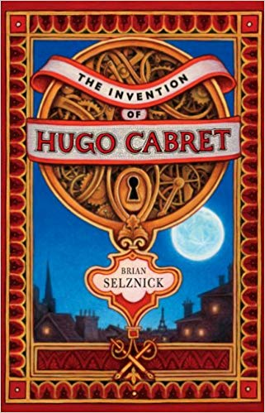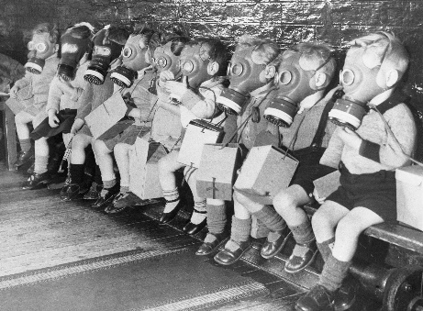

Maths

This half term we will be looking at the place value of digits up to millions, negative numbers and the four operations: addition, subtraction, division and multiplication. We will continue to use fluency, reasoning and problem solving to answer questions and will be continuing to work on our arithmetic skills.

English The Invention of Hugo Cabret Brian Selznick

We will continue our English curriculum with a ‘Book as a Hook.’

Our first book this year is Hugo Cabret. We will use this to write diary entries, monologues and newspaper reports.

Creative Curriculum

World War II

In Creative curriculum we will be: investigating and interpreting the past; understanding chronology and where World War II fits into history; building an overview of world history and communicating historically (using appropriate historical vocabulary and presenting ideas). We will delve into World War II exploring how life was different for people in those times.

PE

The children will participate in one PE lessons a week with Elite coaches. This half term the focus is gymnastics.